Name

Mathematics Advanced Year 11
Multistage Probability and Compound Events

Book 2 | Probability | Version: 260904  Feedback:  https://MrDingMaths.com
Contents
Syllabus Content 2
Probability using Set Notation 3
Listing Outcomes in Multistage Experiments 12
The Multiplication Rule and Probability Trees 19
Probability of Compound Events using Venn Diagrams 37
Compound Events, Venn Diagrams, Set Notation 45

Syllabus Content
MAV-11-10 displays and analyses datasets using summary statistics and graphical representations
Probability
- Define an experiment or a trial to be any procedure that can be infinitely repeated and has a well-defined set of possible outcomes known as the sample space, denoted $S$
- Identify an event $A$ as a subset $A$ of the sample space $S$
- Define the probability of each outcome to be $\frac{1}{\left|S\right|}$ when all the outcomes are equally likely and the probability of the event $A$ to be $P\left(A\right)=\frac{\left|A\right|}{\left|S\right|}$
- Interpret the notation $\bar{A}$ to be the event ‘$A$ does not occur’, interpret $A∩B$ to be the event ‘$A$ and $B$ both occur’, and interpret $A∪B$ to be the event ‘$A$ or $B$ occurs’
- Use Venn diagrams to represent the relationship between events within the same sample space, including mutually exclusive events, that is, events that as subsets of the sample space are disjoint
- Establish and use the rules $P\left(\bar{A}\right)=1-P\left(A\right)$ and $P\left(A∪B\right)=P\left(A\right)+P\left(B\right)-P(A∩B)$
- Use arrays and tree diagrams to determine the outcomes and probabilities for multistage events

Probability using Set Notation

- Experiments and Sample Space
An experiment in probability is any activity that produces results called outcomes.
Each time we repeat an experiment, we call it a trial.
We cannot predict the exact result beforehand. This uncertainty is called randomness.
The sample space $S$ is the set of all possible outcomes for an experiment, without repeats.

- Example list the sample space of an experiment.
  A coin is flipped.  - List all the outcomes.  $Heads, Tails$  - List the sample space.  $S=\{Heads,Tails\}$  - Is each outcome equally likely? Yes. | 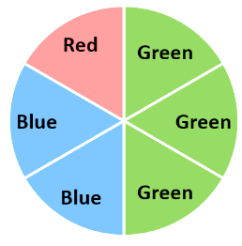  Consider the spinner.  - List all the outcomes.  $G, G, G, B, B, R$  - List the sample space.  $S=\{G, B, R\}$  - Is each outcome equally likely? No.

- Practice
A standard 6-sided die is rolled.  - List the outcomes  1, 2, 3, 4, 5, 6  - List the sample space.  {1, 2, 3, 4, 5, 6}  - Is each number equally likely?  Yes | A jar contains 2 red, 3 yellow, and 4 blue lollies. One is picked out at random.  - List the outcomes.  R ,R, Y, Y, Y, B, B, B, B  - List the sample space.  {R, Y, B}  - Is each colour equally likely?  No

- Key Ideas
- An outcome is a possible ………………… of a chance experiment.
- The sample space lists ………… possible outcomes, without repeats.

- Events
An event is a collection of outcomes.
An event $E$ is a subset of the sample space $S$.

- Probability of an Event
If all outcomes are equally likely, then the probability of a single outcome is $\frac{1}{\left|S\right|}$
The probability of an event is $P\left(E\right)=$ $\frac{\left|E\right|}{\left|S\right|}$
Where $\left|E\right|$ and $\left|S\right|$ are the number of elements in $E$ and $S.$
- If the outcomes are not equally likely, define the sample space such that each outcome is equally likely.
- The probability of every possible outcome must sum to 1.

- Example Calculate probability of an event.
Consider a six-sided die numbered one to six. An experiment involves rolling the die and recording the top face.  - What is $\left|S\right|$?  $$S=\left\{1, 2, 3, 4, 5, 6\right\}$$  $$\left|S\right|=6$$  - What is the probability of rolling a four?  $$four=\left\{4\right\}$$  $$P\left(four\right)=\frac{\left|four\right|}{\left|S\right|}=\frac{1}{6}$$  - What is the probability of rolling a prime number?  $$prime=\left\{1, 2, 3, 5\right\}$$  $$P\left(prime\right)=\frac{\left|prime\right|}{\left|S\right|}=\frac{4}{6}=\frac{2}{3}$$ | Consider the spinner.  An experiment involves  spinning and recording the  section it lands on.  - What is $\left|S\right|$?  $$S=\left\{G_{1},G_{2},G_{3},B_{1},B_{2},R\right\}$$  so that each outcome is equally likely.  $$∴\left|S\right|=6$$  - What is the probability that the spinner lands on a red section $P\left(Red\right)$?  $$red=\left\{R\right\}$$  $$P\left(red\right)=\frac{\left|red\right|}{\left|S\right|}=\frac{1}{6}$$  - What is the probability that the spinner lands on a green section $P\left(Green\right)$?  $$green=\left\{G_{1},G_{2},G_{3}\right\}$$  $$P\left(green\right)=\frac{\left|green\right|}{\left|S\right|}=\frac{3}{6}=\frac{1}{2}$$

- Practice
A 12-sided die numbered 1 to 12 is rolled.  - What is the probability of rolling a factor of 12?  - What is the probability of rolling a prime number?  $$\frac{1}{2},\frac{5}{12}$$ | 20 people were surveyed on their favourite sport. The results are:  Football: 11, Basketball: 2, Tennis: 7  What is the probability a randomly picked person favourites football?  $$\frac{11}{20}$$
- Expected Frequency
A trial is a repetition of an experiment.
Frequency is how often something happens.
Expected frequency is how many times we think an event will happen in a number of trials.

$$\begin{matrix}Expected \\ frequency\end{matrix}=\begin{matrix}Number of \\ trials\end{matrix}×Probability \\ f=np$$

To find expected frequency:
- Find the probability.
- Multiply number of trials by the probability.

- Example Calculate expected frequency of an event.
A coin is flipped 100 times.  How many times would you expect it to land on heads?  1. $P\left(heads\right)=$ $\frac{1}{2}$  2. $f=np$ $=100×$ $\frac{1}{2}$ $=50$ times | 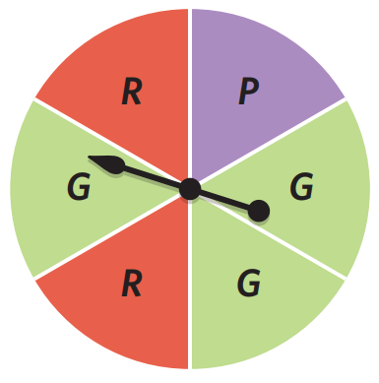  You spin this spinner 120 times.  How many times would you  expect it to land on red or green?  1. $P\left(red or green\right)=$ $\frac{5}{6}$  2. $f=np$ $=120×$ $\frac{5}{6}$ $=100$ times

- Practice
A fair 6-sided die is rolled.  What is the expected frequency of it landing on a four if you roll it 300 times?  $50$ times | Consider the spinner.  How many times would you expect it to land on green or red in 200 spins?  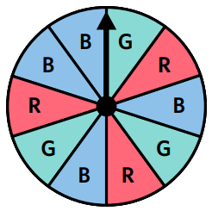  120 times

- Complementary Events
$\overline{E}$ is the complement of $E$. It is the event $E$ not taking place.
An event and its complement cover the sample space.
$$E+\overline{E}=S$$

- Interpret Complementary events.
The event is rolling a three on a six-sided die.  The complementary event is:  not rolling a three: {1,2,4,5,6} | A bag contains red, green, and blue marbles. The event is picking red or blue.  The complementary event is:  Not picking red or blue: {green}
Identify the complement of these events.
- Rolling an even number on a six-sided die. | - Winning a game of table tennis.
- Picking fruit from a box containing chocolates, lollies, fruit. | - Sunny day tomorrow.

- Complement Rule of Probability
The probability of an event and its complement sum to 1.
$$P\left(E\right)+P\left(\overline{E}\right)=1 \\ ∴P\left(\bar{E}\right)=1-P\left(E\right)$$

- Calculate complementary probability.
$P\left(A\right)=0.6$  $P\left(\overline{A}\right)=0.4$ | $$P\left(A\right)=\frac{7}{10}$$  $$P\left(\overline{A}\right)=\frac{3}{10}$$ | $$P\left(\overline{A}\right)=\frac{17}{21}$$  $$P\left(A\right)=\frac{4}{21}$$
Determine the probabilities of the following events in each scenario.
- $P\left(A\right)=0.2$  $$P\left(\overline{A}\right)=$$ | - $P\left(sunny\right)=$ $\frac{13}{20}$  $$P\left(not sunny\right)=$$ | - $P\left(B\right)=0.23$  $$P\left(\overline{B}\right)=$$
- $P\left(\overline{A}\right)=0.75$  $$P\left(A\right)=$$ | - $P\left(green\right)=$ $\frac{11}{30}$  $$P\left(not green\right)=$$ | - $P\left(blue\right)=0.23$  $$P\left(red\right)=$$

- Example Calculate probabilities using complementary outcomes
A pack of 20 cards contains 10 blue, 3 yellow, 3 red, and 4 green.
One card is drawn from the pack.
- Find the probability that the card is green.  $$P\left(G\right)=\frac{4}{20}=\frac{1}{5}$$  - Find the probability that the card is not green.  $$P\left(\overline{G}\right)=1-P\left(G\right) \\ =1-\frac{1}{5} \\ =\frac{4}{5}$$ | Calculate the probability that the card is not green by adding up $P\left(B\right)+P\left(Y\right)+P(R)$  What is the advantage of using complementary events?  In using $1-P\left(G\right),$ we only had to calculate ………… probability instead of three.  The more …………… there are, the more time saved.

- Practice
A pack of 20 cards contains  10 blue, 6 yellow and 4 green.  One card is drawn from the pack.  Find the probability that the card is not yellow.  $$\frac{7}{10}$$ | A bag of 25 cubes contains 3 colours.  There are 7 green cubes.  What is the probability of picking a cube that is not green?  $$\frac{18}{25}$$

- Key Ideas
- The complement of an event is the event ………… happening.
- The probability of an event and its complement must sum to ……………
- We can write “the probability of an event not happening” as $P\left( \right)$
- We can calculate the complement probability by using the formula …………………………

- Deck of Cards
Many questions are based on a deck of 52 playing cards.
- There are four suits: ♠ Spades, ♣ Clubs, ♦ Diamonds, ♥ Hearts.
- Spades and clubs are black, diamonds and hearts are red.
- The number cards are Ace (1), 2, 3, 4, 5, 6, 7, 8, 9, 10.
- The face cards, or picture cards, are Jack, Queen, King.
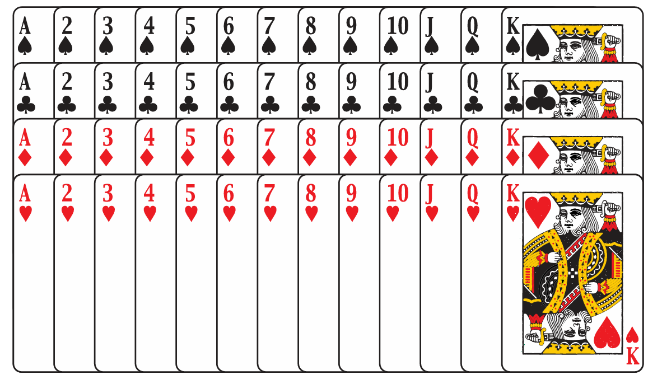

- Identify number of cards meeting a condition in a deck of cards.
Using the image of a deck of cards above, identify how many cards are:
- Picture cards | - Number cards | - Red cards
- Black picture cards | - Red number cards | - Multiples of 2
- Spades | - Number cards that are hearts | - Black cards that are diamonds
- King or jacks | - Less than 5 | - Red queens

Foundation
- A pupil has 3 tickets in the class raffle. If there are 60 tickets in the raffle and one ticket is drawn, find the probability that the pupil:
- wins  $$P\left(wins\right)=\frac{3}{60}=\frac{1}{20}$$ | - does not win  $$P\left(does not win\right)=\frac{57}{60}=\frac{19}{20}$$

- A coin is tossed. Write down the probability that it shows:
- a head  $$P\left(head\right)=\frac{1}{2}$$ | - a tail  $$P\left(tail\right)=\frac{1}{2}$$
- either a head or a tail  $$P(either head or tail) = 1$$ | - neither a head nor a tail  $$P(neither head nor tail) = 0$$

- If a die is rolled, find the probability that the uppermost face is:
- a three  $$P\left(three\right)=\frac{1}{6}$$ | - an even number  $$P\left(even\right)= P\left(2,4,6\right)=\frac{3}{6}=\frac{1}{2}$$
- a number greater than four  $$P\left(greater than 4\right)= P\left(5,6\right)=\frac{2}{6}=\frac{1}{3}$$ | - a multiple of three  $$P\left(multiple of 3\right)= P\left(3,6\right)=\frac{2}{6}=\frac{1}{3}$$

- A bag contains five red and seven blue marbles. If one marble is drawn from the bag at random, find the probability that it is:
- red  $$P\left(red\right)=\frac{5}{12}$$ | - blue  $$P\left(blue\right)=\frac{7}{12}$$ | - green  $$P(green) = 0$$

- A bag contains eight red balls, seven yellow balls and three green balls. A ball is selected at random. Find the probability that it is:
- red  $$P\left(red\right)=\frac{8}{18}=\frac{4}{9}$$ | - yellow or green  $$P\left(yellow or green\right)=\frac{7+3}{18}=\frac{10}{18}=\frac{5}{9}$$ | - not yellow  $$P\left(not yellow\right)=\frac{8+3}{18}=\frac{11}{18}$$

- In a bag there are four red capsicums, three green capsicums, six red apples and five green apples. One item is chosen at random. Find the probability that it is:
- green  $$P\left(green\right)=\frac{3+5}{18}=\frac{8}{18}=\frac{4}{9}$$ | - red  $$P\left(red\right)=\frac{4+6}{18}=\frac{10}{18}=\frac{5}{9}$$ | - an apple  $$P\left(apple\right)=\frac{6+5}{18}=\frac{11}{18}$$
- a capsicum  $$P\left(capsicum\right)=\frac{4+3}{18}=\frac{7}{18}$$ | - a red apple  $$P\left(red apple\right)=\frac{6}{18}=\frac{1}{3}$$ | - a green capsicum  $$P\left(green capsicum\right)=\frac{3}{18}=\frac{1}{6}$$
- A letter is randomly selected from the 26 letters in the English alphabet.
Find the probability that the letter is:
- the letter S  $$P\left(S\right)=\frac{1}{26}$$ | - a vowel  $$P\left(vowel\right)=\frac{5}{26}$$ | - a consonant  $$P\left(consonant\right)=\frac{21}{26}$$
- the letter $δ$  $$P(δ) = 0 (δ not in English alphabet)$$ | - either C, D or E  $$P\left(C,D,E\right)=\frac{3}{26}$$ | - one of the letters of the word MATHS  $$MATHS has letters M,A,T,H,S =\frac{5}{26}$$

- A student has a 22% chance of being chosen as a prefect.
What is the chance that he will not be chosen as a prefect?

P(not chosen) = 1 - 0.22 = 0.78 = 78%
- When breeding labradors, the probability of breeding a black dog is $\frac{5}{7}$.
  - What is the probability of breeding a dog that is not black?
  - If you bred 56 dogs, how many would you expect not to be black?
$$a) P\left(not black\right)= 1 -\frac{5}{7}=\frac{2}{7}$$
$$b) Expected not black = 56 × \left(\frac{2}{7}\right)= 16$$
- A box containing a light bulb has a chance of $\frac{1}{15}$ of holding a defective bulb.
  - If 120 boxes were checked, how many would you expect to hold defective bulbs?
  - What is the probability that the box holds a bulb that works?

$$a) Expected defective = 120 × \left(\frac{1}{15}\right)= 8$$
$$b) P\left(works\right)=1-P\left(defective\right)=\frac{14}{15}$$
- A number is selected at random from the integers 1, 2, 3, ..., 19, 20.
Find the probability of choosing:
- the number 4  $$P\left(4\right)=\frac{1}{20}$$ | - a number greater than 15  $$P\left(16,17,18,19,20\right)=\frac{5}{20}=\frac{1}{4}$$ | - an even number  $$P\left(even\right)=\frac{10}{20}=\frac{1}{2}$$
- an odd number  $$P\left(odd\right)=\frac{10}{20}=\frac{1}{2}$$ | - a prime number  $$P\left(2,3,5,7,11,13,17,19\right)=\frac{8}{20}=\frac{2}{5}$$ | - a square number  $$P\left(1,4,9,16\right)=\frac{4}{20}=\frac{1}{5}$$
- a multiple of 4  $$P\left(4,8,12,16,20\right)=\frac{5}{20}=\frac{1}{4}$$ | - the number $\sqrt{2}$  $$P\left(\sqrt{2}\right)= 0$$ | - a rational number  $$P\left(rational\right)= 1$$

Development
- From a standard pack of 52 cards, one card is drawn at random. Find the probability that:
- it is black  $$P\left(black\right)=\frac{26}{52}=\frac{1}{2}$$ | - it is red  $$P\left(red\right)=\frac{26}{52}=\frac{1}{2}$$ | - it is a king  $$P\left(king\right)=\frac{4}{52}=\frac{1}{13}$$
- it is the jack of hearts  $$P\left(jack of hearts\right)=\frac{1}{52}$$ | - it is a club  $$P\left(club\right)=\frac{13}{52}=\frac{1}{4}$$ | - it is a picture card  $$P\left(picture\right)=\frac{12}{52}=\frac{3}{13}$$
- it is a heart or a spade  $$P\left(heart or spade\right)=\frac{26}{52}=\frac{1}{2}$$ | - it is a red five or a black seven  $$P\left(red 5 or black 7\right)=\frac{4}{52}=\frac{1}{13}$$ | - it is less than a four  $$P\left(less than 4\right)=\frac{12}{52}=\frac{3}{13}$$

- A book has 150 pages. The book is randomly opened at a page.
Find the probability that the page number is:
- greater than 140,  $$P\left(>140\right)=\frac{10}{150}=\frac{1}{15}$$ | - a multiple of 20  $$P\left(multiple of 20\right)=\frac{7}{150}$$ | - an odd number  $$P\left(odd\right)=\frac{75}{150}=\frac{1}{2}$$
- a number less than 25,  $$P\left(<25\right)=\frac{24}{150}=\frac{4}{25}$$ | - either 72 or 111  $$P\left(72 or 111\right)=\frac{2}{150}=\frac{1}{75}$$ | - a three-digit number  $$P\left(three digits\right)=\frac{51}{150}=\frac{17}{50}\left(100 to 150\right)$$

- A bag contains three times as many yellow marbles as blue marbles, and no other colours.
If a marble is chosen at random, find the probability that it is yellow.
$$Let blue = x, then yellow = 3x, total = 4x$$
$$P\left(yellow\right)=\frac{3x}{4x}=\frac{3}{4}$$
- Comment on the following arguments, whether they are correct or incorrect and why.
  - 'When I buy a lottery ticket, there are only two outcomes, either I win or lose.
So, the probability I win is 50%'

Incorrect, the outcomes are not equally likely.
  - 'When answering a multiple-choice test in which there are four possible answers to each question, the chance that Peter answers a question correctly is $\frac{1}{4}$.'

Incorrect, assumes random guessing, Peter likely has knowledge making random guesses unlikely
  - 'A bag contains a number of red, white and black beads. If you choose one bead at random from the bag, the probability that it is black is $\frac{1}{3}$.'
Valid only if equal numbers of each colour, otherwise outcomes not equally likely

Listing Outcomes in Multistage Experiments

- Multistage Experiments
A multistage experiment consists of two or more steps.
For example:
- rolling two dice
- flipping three coins
- flipping a coin, then rolling a die, then picking a card from a deck.

- Independent and Dependent Events
An independent event doesn't change based on previous results.
Example: Flipping a coin twice - the second flip doesn't depend on the first.
A dependent event changes based on previous results.
Example: Taking two marbles from a bag - the second pick depends on the first.

- Identify events as independent or dependent.
- Tossing a coin then tossing another.  - Independent  - Dependent | - Rolling a die then rolling another.  - Independent  - Dependent
- Picking a card from a deck, then picking another one without replacing it.  - Independent  - Dependent | - Picking a card from a deck, replacing it, then picking another card after shuffling.  - Independent  - Dependent
- Tossing a coin then rolling a die.  - Independent  - Dependent | - Choosing a marble from a jar, replacing it, shaking the jar, then choosing another.  - Independent  - Dependent
- Choosing a chocolate from a box,  eating it, then choosing another.  - Independent  - Dependent | - Choosing a marble from a jar then choosing another marble.  - Independent  - Dependent
When an experiment is conducted with replacement, is it independent or dependent?

When an experiment is conducted without replacement, is it independent or dependent?

- Fundamental Counting Principle for Independent Events
For two independent events:
If one event can occur in $m$ ways and another event can occur in $n$ ways,
then both events can occur in $m × n$ ways.

- Calculate total number of outcomes.
- Timmy has two shirts and three trousers.
How many outfit combinations can he have?
$2×3=6$

- Tammy has three shirts and five skirts.
How many outfit combinations can she have?

- A restaurant offers a three-course set menu.
Starter: 3 options | Main: 5 options | Dessert: 2 options
How many meal combinations are there?

- A student ID has six characters. It starts with an English letter and has five digits.
How many students can this ID system support?

- A dice is rolled and a coin is flipped.
How many possible outcomes are there?

- Two dice are rolled and a coin is flipped.
How many possible outcomes are there?

- Listing Outcomes using Tables
A two-way table to records all possible combinations of outcomes for a two-step experiment.
- Use the fundamental counting principle to check you have recorded all possible ways.

- Example List all possible outcomes using a two-way table.
Two four-sided die are rolled and then their results are added.
Complete the table to list all outcomes
 |  | Dice 2
 |  | 1 | 2 | 3 | 4
Dice 1 | 1 | 2 | 3 | 4 | 5
Dice 1 | 2 | 3 | 4 | 5 | 6
Dice 1 | 3 | 4 | 5 | 6 | 7
Dice 1 | 4 | 5 | 6 | 7 | 8

- How many outcomes are there? 16
- What is the probability that the dice sum is 4? $\frac{3}{16}$
- What is the probability that the dice sum is 5 or greater? $\frac{10}{16}=\frac{5}{8}$

- Practice
A two-step experiment involves flipping a coin then rolling a die.
Complete the table to list all outcomes.
 |  | Dice
 |  | 1 | 2 | 3 | 4 | 5 | 6
Coin | H
Coin | T

- What is the total number of outcomes?
12
- What is $P\left(tail\right)$?
$$\frac{1}{2}$$
- What is $P\left(head and 4\right)$?
$$\frac{1}{12}$$
- What is the probability of a head and an odd number?
$$\frac{1}{4}$$

- Listing Outcomes using a Tree Diagram
A tree diagram records all possible combinations of outcomes for a multistage experiment.
Branches represent each possible outcome at every stage.
Outcomes are listed at the end of each complete path.
- Use the fundamental counting principle to check you have recorded all possible ways.

- Example Construct a tree diagram
A fair coin is tossed three times. Use a tree diagram to list all possible outcomes.
1st Toss | 2nd Toss | 3rd toss | Outcomes
H  T | T  H  H  T | H  T  H  T  H  T  H  T | HHH  HHT  HTH  HTT  THH  THT  TTH  TTT
- How many outcomes are there? 8
- What is the probability of two heads and a tail, in that order? $\frac{1}{8}$
- What is the probability of two heads and a tail, in any order? $\frac{3}{8}$

- Practice
A bag contains 2 red discs and 1 green disc. A coin is tossed, and a disc is randomly chosen.
List all possible outcomes using the tree diagram.
Coin Toss | Pick Disc | Outcomes
- How many outcomes are there?
6
- What is the probability of getting tails and a red disc?
$$\frac{1}{3}$$
- What is the probability of getting a red disc?
$$\frac{2}{3}$$

Foundation
- A coin is tossed twice.
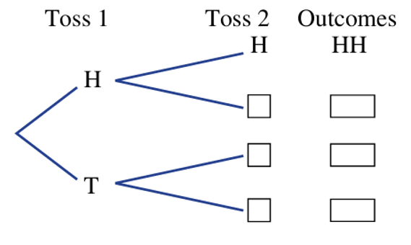
  - Complete this tree diagram to show all the possible outcomes.

All outcomes are HH HT TH TT
  - What is the total number of outcomes?
4
  - Find the probability of obtaining:
- two heads  $$\frac{1}{4}$$ | - one head  $$\frac{1}{2}$$ | - at least one head  $$\frac{3}{4}$$ | - at least one tail  $$\frac{3}{4}$$

- A drawer contains two red socks (R), one blue sock (B) and one yellow sock (Y).
Two socks are selected at random without replacement.
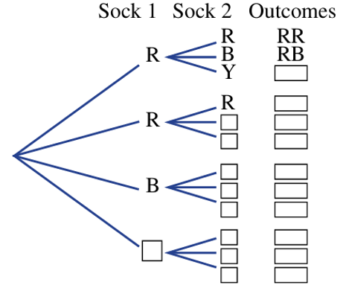
  - Complete this tree diagram.

  - Find the probability of obtaining:
- a red sock and a blue sock  $$\frac{1}{3}$$ | - two red socks  $$\frac{1}{6}$$ | - any pair of socks of the same colour  $$\frac{1}{6}$$ | - any pair of socks of different colour  $$\frac{5}{6}$$

- Two six-sided die are rolled.
  - Complete the table below.
 |  | Die 2
 |  | 1 | 2 | 3 | 4 | 5 | 6
Die 1 | 1 | (1,1) | (2,1) | (3,1) | (4,1) | (5,1) | (6,1)
Die 1 | 2 | (1,2) | (2,2) | (3,2) | (4,2) | (5,2) | (6,2)
Die 1 | 3 | (1,3) | (2,3) | (3,3) | (4,3) | (5,3) | (6,3)
Die 1 | 4 | (1,4) | (2,4) | (3,4) | (4,4) | (5,4) | (6,4)
Die 1 | 5 | (1,5) | (2,5) | (3,5) | (4,5) | (5,5) | (6,5)
Die 1 | 6 | (1,6) | (2,6) | (3,6) | (4,6) | (5,6) | (6,6)

  - What is the total number of outcomes?
$$36$$
  - Find the probability that the outcome is:
- (1,1)  $$\frac{1}{36}$$ | - Two of the same number  $$\frac{1}{6}$$ | - A sum of 4  $$\frac{1}{12}$$ | - Any outcome with 1 or 6  $$\frac{5}{9}$$

- The total sum is recorded from rolling two four-sided dice.
  - Complete the table.
 |  | Die 2
 |  | 1 | 2 | 3 | 4
Die 1 | 1 | 2 | 3 | 4 | 5
Die 1 | 2 | 3 | 4 | 5 | 6
Die 1 | 3 | 4 | 5 | 6 | 7
Die 1 | 4 | 5 | 6 | 7 | 8

  - Find the probability that the outcome is:
- 2  $$\frac{1}{16}$$ | - 2 or 3  $$\frac{3}{16}$$ | - Less than or equal to 4  $$\frac{3}{8}$$ | - More than 6  $$\frac{3}{16}$$

- A spinner with three numbers, 1, 2 and 3, is spun twice.
Each number is equally likely to be spun on a single spin.
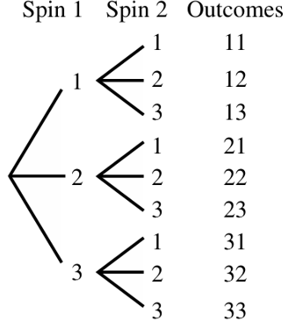
  - List the set of possible outcomes, using a tree diagram.

  - What is the total number of possible outcomes?
9
  - Find the probability of spinning:
- two 3s  $$\frac{1}{9}$$ | - at least one 3  $$\frac{5}{9}$$ | - no more than one 2  $$\frac{8}{9}$$ | - two odd numbers  $$\frac{4}{9}$$

- Two lollipops are selected at random without replacement from a group of three:
strawberry (S), grape (G) and cola (C).
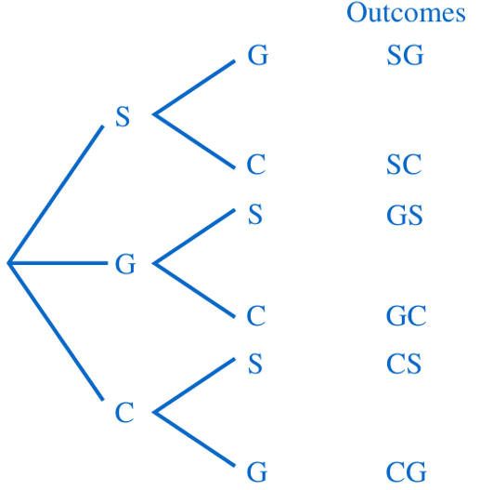
  - List all the possible outcomes for the selection using a tree diagram.

  - Find the probability that the selection will contain:
- strawberry and cola  $$\frac{1}{3}$$ | - grape  $$\frac{2}{3}$$ | - grape or cola  $$1$$

The Multiplication Rule and Probability Trees

- Multiplication Rule for Multistage Experiments
If two successive events $A$ and $B$ in a multistage experiment are independent, then:
$$P\left(A and B\right)=P\left(A\right)×P\left(B\right)$$
- We can write $P\left(A and B\right)$ as $P\left(AB\right)$ and $P\left(A,B\right)$ and $P\left(A∩B\right)$.
- Note that $P\left(A and B\right)$ is not always equal to $P\left(B and A\right)$ for multistage probability.

- Example Determine probabilities for independent events using
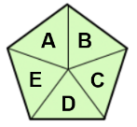  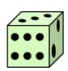  Alex is rolling a dice and spinning a spinner.  What is the probability that he gets:  - 2 on the die and B on the spinner?  $$P\left(2,B\right)=P\left(2\right)×P\left(B\right) \\ =\frac{1}{6}×\frac{1}{5}=\frac{1}{30}$$  - An odd number on the die and a vowel on the spinner?  $$P\left(odd, vowel\right)=P\left(odd\right)×P\left(vowel\right) \\ =\frac{3}{6}×\frac{2}{5}=\frac{6}{30}=\frac{1}{5}$$ | What does $P\left(2 and B\right)$ mean?  Probability of getting ……… in the first stage and ……… in the second stage.  Where did the fractions $\frac{1}{6}$ and $\frac{1}{5}$ come from?  The probability of getting …… is $\frac{1}{6}$  The probability of getting …… is $\frac{1}{5}$  Show why this works using the table.
   | A | B | C | D | E
  1 | 1,A | 1,B | 1,C | 1,D | 1,E
  2 | 2,A | 2,B | 2,C | 2,D | 2,E
  3 | 3,A | 3,B | 3,C | 3,D | 3,E
  4 | 4,A | 4,B | 4,C | 4,D | 4,E
  5 | 5,A | 5,B | 5,C | 5,D | 5,E
  6 | 6,A | 6,B | 6,C | 6,D | 6,E

- Practice
Alison is rolling a die and spinning a spinner.
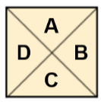

What is the probability that she gets:
- 1 on the die and  C on the spinner.  $$\frac{1}{24}$$ | - An even number and a consonant.  $$\frac{3}{8}$$ | - A number greater than 4 and a vowel.  $$\frac{1}{12}$$
- Probability Trees with Independent Events
- A probability tree is a tree diagram with probabilities on its branches.
- We use probability trees when each event has a different probability, or when there are too many outcomes to list.
- Calculate an event’s probability by multiplying the probabilities along the branches.

- Interpret probability trees
A bag contains 4 purple and 3 green marbles, and a second bag contains 2 purple and 3 green marbles. A marble is picked out of each bag.
Bag 1 | Bag 2

The tree diagram of this situation is below to the left.
Comment on its appropriateness for representing this problem.

When working with probability, we do not need to list each outcome.
We can calculate the probability of each event instead.
A probability tree shows the events and their probabilities at each stage.
To find the probability of an event, we multiply the probabilities along the branches

Calculate the probability of selecting a green marble and a purple marble, in that order,
using both trees.

Tree diagram listing outcomes |  |  | Probability tree listing events
Bag 1 | Bag 2 | Outcomes | Bag 1 | Bag 2 | Events
P  P  P  P  G  G  G | P  P  G  G  G  P  P  G  G  G  P  P  G  G  G  P  P  G  G  G  P  P  G  G  G  P  P  G  G  G  P  P  G  G  G | PP  PP  PG  PG  PG  PP  PP  PG  PG  PG  PP  PP  PG  PG  PG  PP  PP  PG  PG  PG  GP  GP  GG  GG  GG  GP  GP  GG  GG  GG  GP  GP  GG  GG  GG | $$\frac{4}{7}$$  P  $$\frac{3}{7}$$  G | $$\frac{2}{5}$$  P  $$\frac{3}{5}$$  G  $$\frac{2}{5}$$  P  $$\frac{3}{5}$$  G | $$P\left(PP\right)=$$  $$P\left(PG\right)=$$  $$P\left(GP\right)=$$  $$P\left(GG\right)=$$

- Probability Trees with Independent Events
- Draw a tree diagram where each stage appears as a separate branch.
- Label each branch with the probability of that single-stage event occurring.
- Calculate probability of each event by multiplying probabilities along each path.
- Answer question. When the question asks for multiple events, choose one method:
  - Add the probabilities of all relevant events together, OR
  - Use $1-P(none)$ when the question asks for “at least one.”
- The probabilities on any pair of branches should sum to 1.
- All final events should sum to 1.
- It is a good idea to leave probabilities as unsimplified fractions.

- Example Calculate probability of multistage events using probability trees.
A bag contains 7 red and 5 blue marbles.
A second bag has 4 red and 3 blue.
- What is the probability of drawing a red marble and a blue marble, in any order?
- What is the probability of drawing at least one red marble?
1. Draw tree diagram
1st Stage | 2nd Stage | Events
R  B | R  B  R  B | RR  RB  BR  BB
2. Label branches
3. Calculate probabilities
1st Stage | 2nd Stage | Events
R  $$\frac{3}{7}$$  $$\frac{7}{12}$$  $$\frac{5}{12}$$  B | R  $$\frac{4}{7}$$  B  $$\frac{4}{7}$$  R  $$\frac{3}{7}$$  B | $$P\left(RR\right)=\frac{7}{12}×\frac{4}{7}=\frac{28}{84}$$  $$P\left(RB\right)=\frac{7}{12}×\frac{3}{7}=\frac{21}{84}$$  $$P\left(BR\right)=\frac{5}{12}×\frac{4}{7}=\frac{20}{84}$$  $$P\left(BB\right)=\frac{5}{12}×\frac{3}{7}=\frac{15}{84}$$
4. Answer questions
$$a. P\left(RB\right)+P\left(RB\right)=\frac{21}{84}+\frac{20}{84}=\frac{41}{84}$$
$$b. P\left(RR\right)+P\left(RB\right)+P\left(BR\right)=\frac{28}{84}+\frac{21}{84}+\frac{20}{24}=\frac{69}{84}$$
$$OR: 1-P\left(BB\right)=1-\frac{15}{84}=\frac{69}{84}$$
- Practice
A bag contains 12 green counters and 8 red counters.
Faith removes a counter, writes down its colour then puts it back in the bag.
She then selects another counter and writes down its colour.
- Find the probability that Faith selects two green counters.
- Find the probability that Faith selects at least one green counter.

$$a) \frac{144}{400}=\frac{9}{25}$$
$$b) \frac{336}{400}=\frac{21}{25}$$
Becky has a maths test and then a science test.
She has a 80% chance of passing her maths test.
She has a 60% chance of passing her science test.
- Find the probability she passes only one of the exams.
- Find the probability she passes at least one of the exams.

$$a) 44\%$$
$$b) 92\%$$
- Complementary Events of “At Least One”
The complement of "at least one" is "none".

- Identify the complementary event of “at least one”
Identify the complement of these scenarios.
A coin is flipped four times.  What is the complementary event to  “at least one head”? | You roll a fair six-sided die three times.  What is the complementary event to  "at least one roll is a 6"?
From a shuffled deck of 52 cards, 6 cards are drawn.  What is the complementary event to  "at least one card drawn is a spade"? | You flip a fair coin five times.  What is the complementary event to  "at least one flip results in tails"?
A bag contains 5 red marbles, 3 blue marbles, and 2 green marbles.  Three marbles are drawn.  What is the complementary event to  "at least one marble drawn is red"? | In a class of 30 students, 15 are male and 15 are female. Three students are randomly selected  What is the complementary event to  "at least one student selected is male"?

- Probability of “At Least One”
$$P\left(a least one\right)=1-P\left(none\right)$$

- Interpret the complementary event of “at least one”
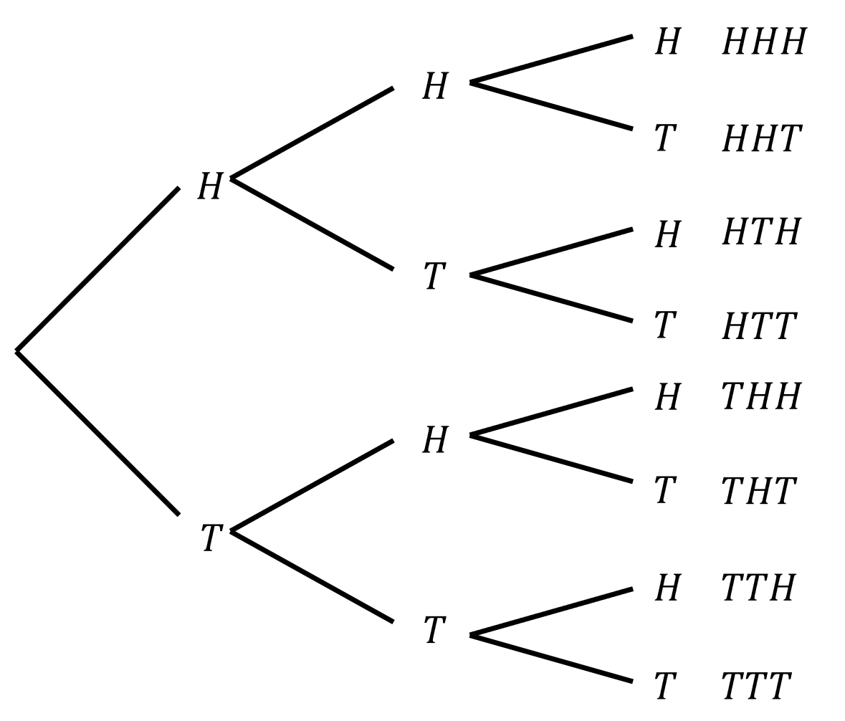
Three coins are flipped. The tree diagram is given.
- What is the probability of no tails?

- What is the probability of at least one tail?

- Does $P\left(at least one\right)=1-P\left(none\right)?$

- A fair die is rolled twice.  What is the probability of no 6s?  What is the probability of at least one 6? | - A spinner has 4 equal sections: red, blue, green, yellow. It's spun 3 times.  What is the probability of no reds?  What is the probability of at least one red?
- A bag contains 3 red balls and 7 blue balls. Two balls are drawn with replacement.  What is the probability of at least one red ball? | - A student guesses on 3 multiple-choice questions. Each question has probability ¼ of being correct.  What is the probability of at least one correct answer?
- A basketball player has a 60% free-throw success rate. She attempts 3 shots.  What is the probability of at least one successful shot? | - A quality control test checks 5 items. Each item has a 5% chance of being defective.  What is the probability of at least one defective item?

- Probability Trees with Dependent Events
- Dependent events occur when there is no replacement.
- Draw a tree diagram where each stage appears as a separate branch.
- Label each branch with the probability of that single-stage event occurring.
- Calculate probability of each event by multiplying probabilities along each path.
- Answer question. When the question asks for multiple events, choose one method:
  - Add the probabilities of all relevant events together, OR
  - Use $1-P(none)$ when the question asks for “at least one.”
- The probabilities on any pair of branches should sum to 1.
- All final events should sum to 1.
- It is a good idea to leave probabilities as unsimplified fractions.

- Example Calculate probability of multistage events using probability trees.
A bag contains 3 red marbles and 5 blue marbles.
Two are taken from the same bag without replacement.
- What is the probability of drawing a red marble and a blue marble, in any order?
- What is the probability of drawing at least one red marble?

1st Stage | 2nd Stage | Events
R  $$\frac{5}{7}$$  $$\frac{3}{8}$$  $$\frac{5}{8}$$  B | R  $$\frac{2}{7}$$  B  $$\frac{4}{7}$$  R  $$\frac{4}{7}$$  B | $$P\left(RR\right)=\frac{3}{8}×\frac{2}{7}=\frac{6}{56}$$  $$P\left(RB\right)=\frac{3}{8}×\frac{5}{7}=\frac{15}{56}$$  $$P\left(BR\right)=\frac{5}{8}×\frac{3}{7}=\frac{15}{56}$$  $$P\left(BB\right)=\frac{5}{8}×\frac{4}{7}=\frac{20}{56}$$

$$a. P\left(RB\right)+P\left(RB\right)=\frac{15}{56}+\frac{15}{56}=\frac{30}{56}$$
$$b. P\left(RR\right)+P\left(RB\right)+P\left(BR\right)=\frac{6}{56}+\frac{15}{56}+\frac{15}{56}=\frac{36}{56}=\frac{9}{14}$$
$$OR: 1-P\left(BB\right)=1-\frac{20}{56}=\frac{9}{14}$$

- Practice
A bag contains 4 black counters and 8 white counters.
Hannah takes two counters out of the bag at random without replacing the first.
- Find the probability that Hannah selects two counters of the same colour.
- Find the probability that Hannah selects at least one white counter.

$$a) \frac{68}{132}=\frac{17}{33}$$
$$b) \frac{120}{132}=\frac{10}{11}$$
A box contains 2 milk chocolates and 7 dark chocolates.
Miki selects a chocolate at random, eats it, and selects a second.
Find the probability:
- She picks two milk chocolates.
- Two different types of chocolates.
- Two chocolates of the same type.
- At least one dark chocolate.

$$a)\frac{2}{72}=\frac{1}{36}$$
$$b)\frac{28}{72}=\frac{7}{18}$$
$$c)\frac{44}{72}=\frac{11}{18}$$
$$d)\frac{70}{72}=\frac{35}{36}$$

Foundation
- Suppose that A, B, C and D are independent events, with
$$P\left(A\right)=\frac{1}{8}, P\left(B\right)=\frac{1}{3}, P\left(C\right)=\frac{1}{4} and P\left(D\right)=\frac{2}{7}$$
Use the product rule to find:
- P(AB)  $$\frac{1}{24}$$ | - P(AD)  $$\frac{1}{28}$$ | - P(BC)  $$\frac{1}{12}$$
- P(ABC)  $$\frac{1}{96}$$ | - P(BCD)  $$\frac{1}{42}$$ | - P(ABCD)  $$\frac{1}{336}$$

- A coin and a die are tossed. Use the product rule to find the probability of obtaining:
- a three and a head  $$P\left(3 and H\right)= \left(\frac{1}{6}\right)\left(\frac{1}{2}\right)=\frac{1}{12}$$ | - a six and a tail  $$P\left(6 and T\right)= \left(\frac{1}{6}\right)\left(\frac{1}{2}\right)=\frac{1}{12}$$
- an even number and a tail  $$P\left(even and T\right)= \left(\frac{3}{6}\right)\left(\frac{1}{2}\right)=\frac{3}{12}=\frac{1}{4}$$ | - a number less than five and a head  $$P\left(<5 and H\right)= \left(\frac{4}{6}\right)\left(\frac{1}{2}\right)=\frac{4}{12}=\frac{1}{3}$$

- Two marbles are picked at random, one from a bag containing three red and four blue marbles, and the other from a bag containing five red and two blue marbles.
Find the probability of drawing:
- two red marbles  $$P\left(2 red\right)= \left(\frac{3}{7}\right)\left(\frac{5}{7}\right)=\frac{15}{49}$$ | - two blue marbles  $$P\left(2 blue\right)= \left(\frac{4}{7}\right)\left(\frac{2}{7}\right)=\frac{8}{49}$$ | - a red marble from the first bag and a blue marble from the second  $$P\left(R, B\right)= \left(\frac{3}{7}\right)\left(\frac{2}{7}\right)=\frac{6}{49}$$

- A box of chocolates contains 3 Freddo Frogs and 1 Caramello Koalas.
Two chocolates are taken out of the box without replacement.
  - If the first chocolate was a Freddo Frog,
What is the probability the second chocolate is a Freddo Frog?
$$\frac{2}{3}$$
  - If the first chocolate was a Freddo Frog,
What is the probability the second chocolate is a Caramello Koala?
$$\frac{1}{3}$$
  - If the first chocolate was a Caramello Koala,
What is the probability the second chocolate is Freddo Frog?
$$1$$
  - If the first chocolate was a Caramello Koala,
What is the probability the second chocolate is Caramello Koala?
$$0$$
- A box contains five light bulbs, two of which are faulty.
Two bulbs are selected, one at a time without replacement. Find the probability that:
- both bulbs are faulty  $$P\left(both faulty\right)= \left(\frac{2}{5}\right)\left(\frac{1}{4}\right)=\frac{2}{20}=\frac{1}{10}$$ | - neither bulb is faulty  $$P\left(neither faulty\right)= \left(\frac{3}{5}\right)\left(\frac{2}{4}\right)=\frac{6}{20}=\frac{3}{10}$$
- the first bulb is faulty and the second one is not  $$P\left(1st faulty, 2nd not\right)= \left(\frac{2}{5}\right)\left(\frac{3}{4}\right)=\frac{6}{20}=\frac{3}{10}$$ | - the second bulb is faulty and the first one is not  $$P\left(1st not faulty, 2nd faulty\right)= \left(\frac{3}{5}\right)\left(\frac{2}{4}\right)=\frac{6}{20}=\frac{3}{10}$$

- A box contains twelve red and ten green discs.
Three discs are selected, one at a time with replacement
  - What is the probability that the discs selected are red, green, red in that order?

$$P\left(R,G,R\right)= \left(\frac{12}{22}\right)\left(\frac{10}{22}\right)\left(\frac{12}{22}\right)=\frac{1440}{10648}=\frac{180}{1331}$$
  - What is the probability of this event if the disc is not replaced after each draw?

$$P\left(R,G,R\right)= \left(\frac{12}{22}\right)\left(\frac{10}{21}\right)\left(\frac{11}{20}\right)=\frac{1320}{9240}=\frac{1}{7}$$

- A bag contains three black and four white discs. A disc is selected from the bag, its colour is noted, and it is then returned to the bag before a second disc is drawn.
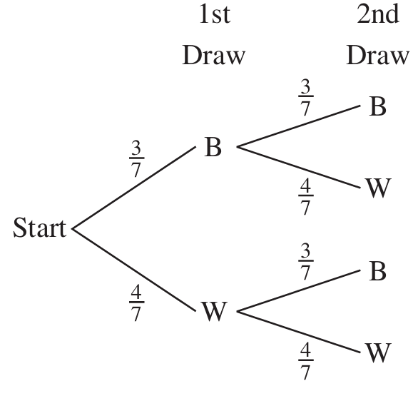
  - By multiplying along the branches of the tree, find:
    - P(BB)
$$\frac{9}{49}$$
    - P(BW)
$$\frac{12}{49}$$
    - P(WB)
$$\frac{12}{49}$$
    - P(WW)
$$\frac{16}{49}$$
  - Hence, by adding, find the probability that:
    - both discs drawn have the same colour,
$$P\left(same colour\right)= P\left(BB\right)+ P\left(WW\right)=\frac{9}{49}+\frac{16}{49}=\frac{25}{49}$$
    - the discs drawn have different colours.
$$P\left(different colours\right)= P\left(BW\right)+ P\left(WB\right)=\frac{12}{49}+\frac{12}{49}=\frac{24}{49}$$

- Two light bulbs are selected at random from a large batch of bulbs in which 5% are defective.
  - By multiplying along the branches of the tree, find:
    - P(both bulbs work),
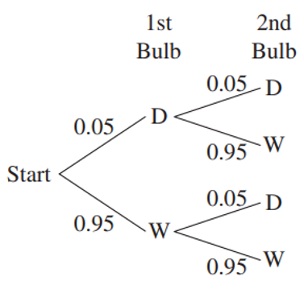
P(both work) = (0.95)(0.95) = 0.9025 = 90.25%
    - P(the first works, but the second is defective),

P(1st works, 2nd defective) = (0.95)(0.05) = 0.0475 = 4.75%
    - P(the first is defective, but the second works),

P(1st defective, 2nd works) = (0.05)(0.95) = 0.0475 = 4.75%
    - P(both bulbs are defective).

P(both defective) = (0.05)(0.05) = 0.0025 = 0.25%
  - Hence find the probability that at least one bulb works.

P(at least one works) = 1 - P(both defective) = 1 - 0.0025 = 0.9975 = 99.75%

- One bag contains three red and two blue balls and another bag contains two red and three blue balls. A ball is drawn at random from each bag.
  - Complete the tree diagram by writing the probabilities on the branches.
  - By multiplying along the branches of the tree, find:
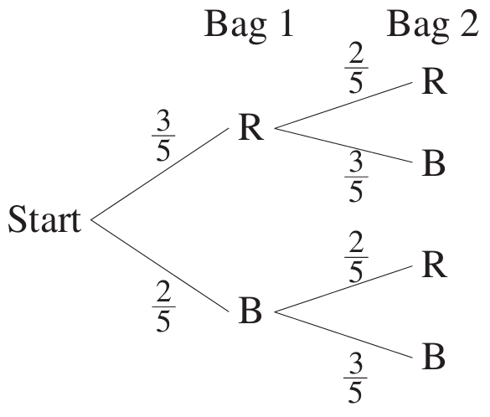
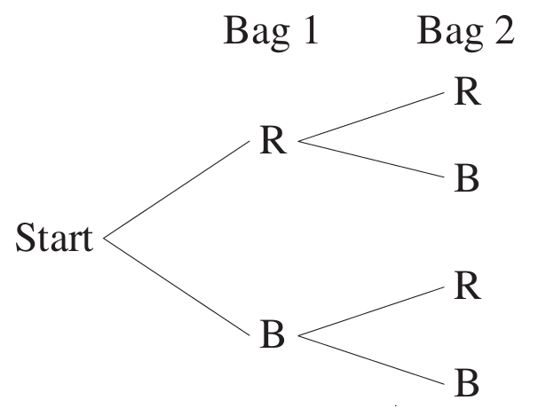
    - P(RR)
$$P\left(RR\right)= \left(\frac{3}{5}\right)\left(\frac{2}{5}\right)=\frac{6}{25}$$
    - P(RB)
$$P\left(RB\right)= \left(\frac{3}{5}\right)\left(\frac{3}{5}\right)=\frac{9}{25}$$
    - P(BR)
$$P\left(BR\right)= \left(\frac{2}{5}\right)\left(\frac{2}{5}\right)=\frac{4}{25}$$
    - P(BB)
$$P\left(BB\right)= \left(\frac{2}{5}\right)\left(\frac{3}{5}\right)=\frac{6}{25}$$
  - Hence, by adding, find the probability that:
    - the balls have the same colour,
$$P\left(RR\right)+ P\left(BB\right)=\frac{6}{25}+\frac{6}{25}=\frac{12}{25}$$
    - the balls have different colours.
$$P\left(RB\right)+ P\left(BR\right)=\frac{9}{25}+\frac{4}{25}=\frac{13}{25}$$

Development
- A bag contains 5 blue (B) and 3 white (W) marbles.
Mary picks 2 marbles without replacement.
  - Complete the tree diagram by writing the probabilities on the branches and the probability of each event.
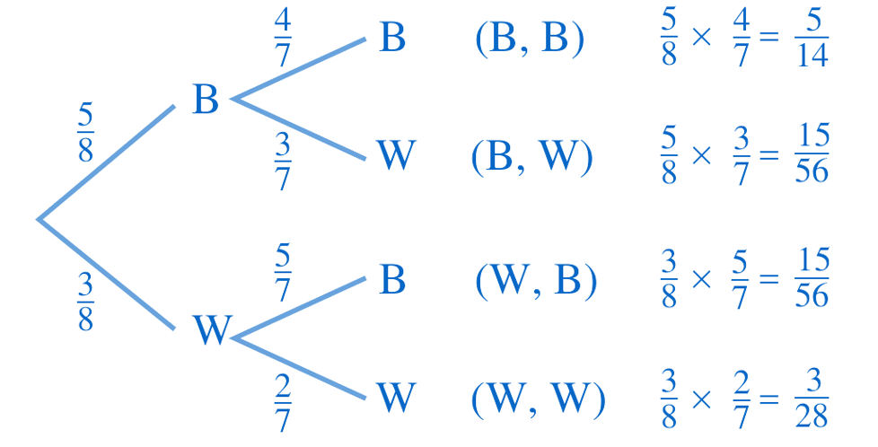
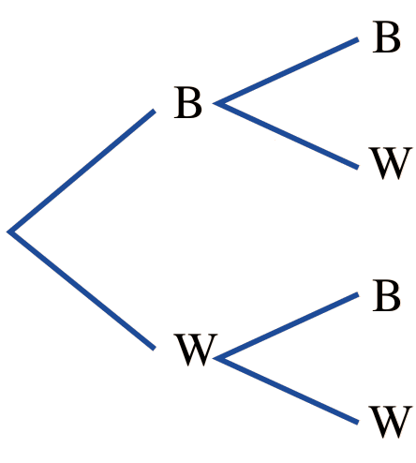

  - Find the probability of selecting:
- Two blue marbles  $$\frac{5}{14}$$ | - A blue and a white in that order  $$\frac{15}{56}$$ | - One of each colour  $$P\left(BW\right)+P\left(WB\right)=\frac{30}{56}=\frac{15}{28}$$ | - At least one blue marble  $$1-P\left(WW\right)=\frac{25}{28}$$

- In group A there are three girls and seven boys, and in group B there are six girls and four boys. One person is chosen at random from each group.
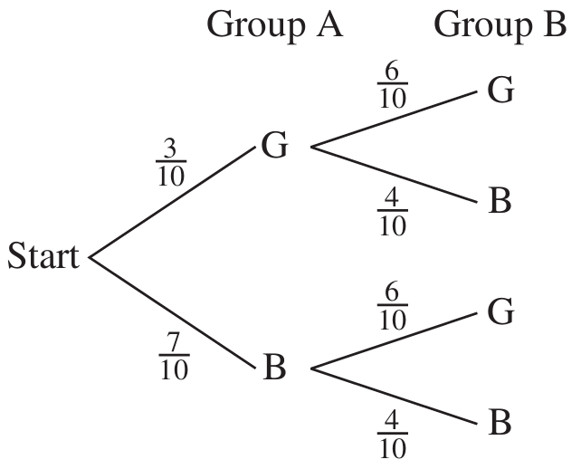
  - Draw a probability tree diagram.

  - By multiplying along the branches of the tree, find:
- P(GG)  $$P\left(GG\right)= \left(\frac{3}{10}\right)\left(\frac{6}{10}\right)=\frac{18}{100}=\frac{9}{50}$$ | - P(GB)  $$P\left(GB\right)= \left(\frac{3}{10}\right)\left(\frac{4}{10}\right)=\frac{12}{100}=\frac{3}{25}$$ | - P(BG)  $$P\left(BG\right)= \left(\frac{7}{10}\right)\left(\frac{6}{10}\right)=\frac{42}{100}=\frac{21}{50}$$ | - P(BB)  $$P\left(BB\right)= \left(\frac{7}{10}\right)\left(\frac{4}{10}\right)=\frac{28}{100}=\frac{7}{25}$$

  - Hence, by adding, find the probability that:
- two boys or two girls are chosen  $$P\left(GG\right)+ P\left(BB\right)=\frac{9}{50}+\frac{14}{50}=\frac{23}{50}$$ | - one boy and one girl are chosen  $$P\left(GB\right)+ P\left(BG\right)=\frac{6}{50}+\frac{21}{50}=\frac{27}{50}$$
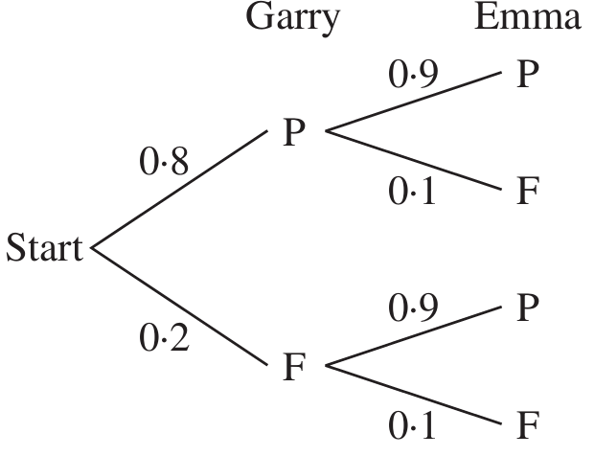
- There is an 80% chance that Garry will pass his driving test and a 90% chance that Emma will pass hers.
Draw a probability tree diagram.

find the chance that
- Garry passes and Emma fails  $$\left(0.8\right)\left(0.1\right)= 0.08 = 8\%$$ | - Garry fails and Emma passes  $$\left(0.2\right)\left(0.9\right)= 0.18 = 18\%$$
- only one of Garry and Emma passes  $$8\% + 18\% = 26\%$$ | - at least one fails  $$1 - P\left(both pass\right)= 1 - \left(0.8\right)\left(0.9\right)= 28\%$$

- Two animals are selected from rabbits (R) and 4 guinea pigs (G) without replacement.
Draw a tree diagram and the find the probability of each possible event.
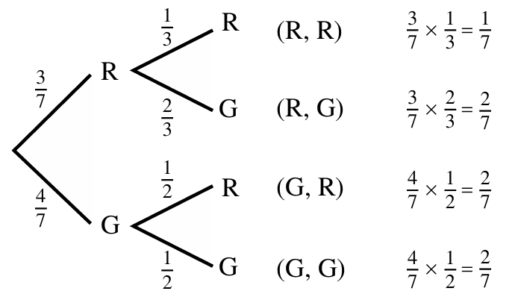

What is the probability of selecting
- 1 of each animal  $$P\left(RG\right)+P\left(GR\right)=\frac{4}{7}$$ | - 2 of the same animal  $$P\left(RR\right)+P\left(GG\right)=\frac{3}{7}$$
- No rabbits  $$P\left(GG\right)=\frac{2}{7}$$ | - At least one rabbit  $$1-P\left(GG\right)=\frac{5}{7}$$

- The probability that a set of traffic lights will be green when you arrive at them is 0.6.
A motorist drives through two sets of lights. Assuming that the two sets of traffic lights are independent of each other, find the probability that:
  - both sets of lights will be green,
  - at least one set of lights will be green.

$$a) P\left(both green\right)= \left(\frac{3}{5}\right)\left(\frac{3}{5}\right)=\frac{9}{25}$$
$$b) P\left(at least one green\right)= 1 - P\left(both not green\right)= 1 - \left(\frac{2}{5}\right)\left(\frac{2}{5}\right)= 1 -\frac{4}{25}=\frac{21}{25}$$
- A factory assembles calculators. Each calculator requires a chip and a battery.
It is known that 1% of chips and 4% of batteries are defective.
Find the probability that a calculator selected at random will have at least one defective component.

P(at least one defective) = 1 - P(both work) = 1 - (0.99)(0.96) = 1 - 0.9504 = 0.0496 = 4.96%
- The probability of a woman being alive at 80 years of age is 0.2, and the probability of her husband being alive at 80 years of age is 0.05. Find the probability that:
  - they will both live to be 80 years of age,
  - only one of them will live to be 80.

a) P(both alive at 80) = (0.2)(0.05) = 0.01
b) P(only one alive at 80) = (0.2)(0.95) + (0.8)(0.05) = 0.19 + 0.04 = 0.23

Mastery
- In a raffle in which there are 200 tickets, the first prize is drawn and then the second prize is drawn without replacing the winning ticket. If you buy 15 tickets, find the probability that you win:
  - both prizes,
  - at least one prize.

$$P\left(both prizes\right)= \left(\frac{15}{200}\right)× \left(\frac{14}{199}\right)=\frac{210}{39800}=\frac{21}{3980}$$
$$P(at least one) = 1 - P(no prizes)= 1 - \left(\frac{185}{200}\right)× \left(\frac{184}{199}\right)= \frac{144}{995}$$
- A box contains 10 chocolates, all of identical appearance. Three of the chocolates have caramel centres and the other seven have mint centres. Hugo randomly selects and eats three chocolates from the box. Find the probability that:
  - the first chocolate Hugo eats is caramel,
  - Hugo eats three mint chocolates,
  - Hugo eats exactly one caramel chocolate.

$$P\left(1st is caramel\right)=\frac{3}{10}$$
$$P\left(three mint\right)= \left(\frac{7}{10}\right)× \left(\frac{6}{9}\right)× \left(\frac{5}{8}\right)=\frac{210}{720}=\frac{7}{24}$$
$$P\left(exactly one caramel\right)= 3 × \left(\frac{3}{10}\right)× \left(\frac{7}{9}\right)× \left(\frac{6}{8}\right)=\frac{378}{720}=\frac{21}{40}$$
- In an aviary there are four canaries, five cockatoos and three budgerigars. If two birds are selected at random, find the probability that:
  - both are canaries,
  - neither is a canary,
  - one is a canary and one is a cockatoo,
  - at least one is a canary.

$$P\left(both canaries\right)= \left(\frac{4}{12}\right)× \left(\frac{3}{11}\right)=\frac{12}{132}=\frac{1}{11}$$
$$P\left(neither canary\right)= \left(\frac{8}{12}\right)× \left(\frac{7}{11}\right)=\frac{56}{132}=\frac{14}{33}$$
$$P\left(one canary, one cockatoo\right)= 2 × \left(\frac{4}{12}\right)× \left(\frac{5}{11}\right)=\frac{40}{132}=\frac{10}{33}$$
$$P\left(at least one canary\right)= 1 - P\left(neither canary\right)= 1 -\frac{14}{33}=\frac{19}{33}$$
- Max and Jack each throw a die. Find the probability that:
  - they do not throw the same number,
  - the number thrown by Max is greater than the number thrown by Jack,
  - the numbers they throw differ by three.

A two-way table is useful for this question.
$$P\left(different numbers\right)= 1 - P\left(same\right)= 1 -\frac{6}{36}=\frac{30}{36}=\frac{5}{6}$$
$$P\left(Max > Jack\right)=\frac{15}{36}=\frac{5}{12}$$
$$P\left(differ by 3\right)=\frac{6}{36}=\frac{1}{6}$$
- A game is played in which two coloured dice are rolled once.
The six faces of the black die are numbered 5, 7, 8, 10, 11, 14.
The six faces of the white die are numbered 3, 6, 9, 12, 13, 15.
The player wins if the number on the black die is bigger than the number on the white die.
  - Calculate the probability of a player winning the game.
  - Calculate the probability that a player will lose at least once in two consecutive games.
  - How many games must be played before you have a 90% chance of winning at least one game? (hint: set up an equation and use logarithms)

A two-way table is useful for this question
$$P\left(win\right)=\frac{16}{36}=\frac{4}{9}$$
$$P\left(lose at least once in 2 games\right)= 1 - P\left(win both\right)$$
$$= 1 - {\left(\frac{4}{9}\right)}^{2}= 1 -\frac{16}{81}=\frac{65}{81}$$

$$P(win at least once in n games) ≥ 0.9$$
$$1 - {\left(\frac{5}{9}\right)}^{n} ≥ 0.9$$
$${\left(\frac{5}{9}\right)}^{n} ≤ 0.1$$
$$n ≥\log_{\frac{5}{9}}{0.1}≥3.917…$$
$$∴4 games or more$$
Note: we flip the inequality when taking a log of a base that is less than one.
You do not need to know this fact; intuitively, it must be more than 4 games, not less than 4.

- An interviewer conducts a poll in Sydney and Melbourne on the popularity of the prime minister. In Sydney, 52% of the population approve of the prime minister, and in Melbourne her approval rating is 60%. If one of the two capital cities is selected at random and two electors from that city are surveyed, find the probability that:
  - both electors approve of the prime minister,
  - at least one elector approves of the prime minister.

A three-stage tree diagram is needed here.

$$a) P\left(Syd,Approve,Approve\right)+P\left(Mel, Approve,Approve\right)=\left(0.5\right)\left(0.52\right)\left(0.52\right)+\left(0.5\right)\left(0.6\right)\left(0.6\right)=31.52\%$$

$$b) 1-P\left(both disapprove\right)=1-\left(P\left(Syd, Disapprove,Disapprove\right)+P\left(Mel,Disapprove,Disapprove\right)\right)$$
$$=1-\left(\left(0.5\right)\left(0.48\right)\left(0.48\right)+\left(0.5\right)\left(0.4\right)\left(0.4\right)\right)$$
$$=80.48\%$$

- In a bag there are four green, three blue and five red discs.
Two discs are drawn at random, and the first disc is not replaced before the second disc is drawn. Find the probability of drawing:
  - two red discs,
  - one red and one blue disc,
  - at least one green disc,
  - a blue disc on the first draw,
  - two discs of the same colour,
  - two differently coloured discs.

$$P\left(two red\right)= \left(\frac{5}{12}\right)\left(\frac{4}{11}\right)=\frac{20}{132}=\frac{5}{33}$$

$$P\left(one red, one blue\right)= \left(\frac{5}{12}\right)\left(\frac{3}{11}\right)+ \left(\frac{3}{12}\right)\left(\frac{5}{11}\right)=\frac{30}{132}=\frac{5}{22}$$

$$P\left(at least one green\right)= 1 - P\left(no green\right)= 1 - \left(\frac{8}{12}\right)\left(\frac{7}{11}\right)= 1 -\frac{56}{132}=\frac{76}{132}=\frac{19}{33}$$

$$P\left(blue first\right)=\frac{3}{12}=\frac{1}{4}$$

$$P(same colour) = P(two green) + P(two blue) + P\left(two red\right)$$
$$= \left(\frac{4}{12}\right)\left(\frac{3}{11}\right)+ \left(\frac{3}{12}\right)\left(\frac{2}{11}\right)+ \left(\frac{5}{12}\right)\left(\frac{4}{11}\right)=\frac{19}{66}$$

$$P\left(different colours\right)= 1 - P\left(same colour\right)= 1 -\frac{19}{66}=\frac{47}{66}$$
- HSC Advanced Sample Question Band 5
A box contains $n$ marbles, of which $k$ marbles are coloured red and the remainder of the marbles are coloured green. Two marbles are drawn randomly from the box.
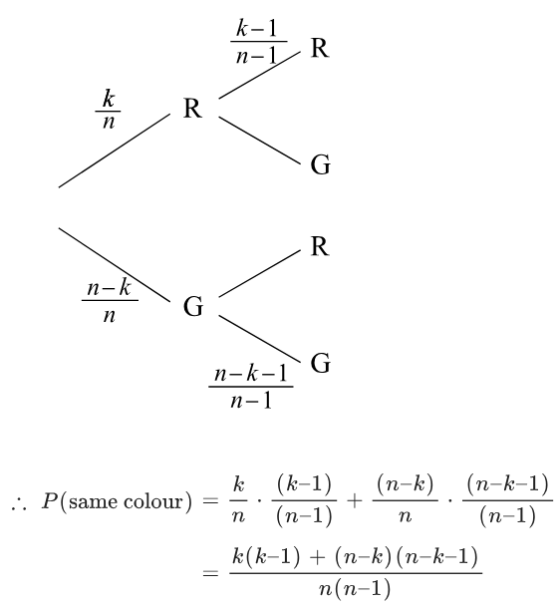
If the first marble is not replaced into the box before the second marble is drawn, then the probability that the two marbles drawn are the same colour is:
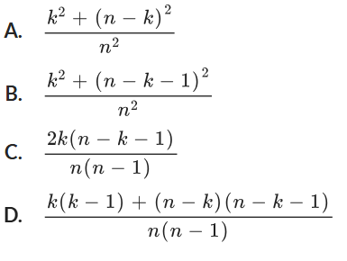

D

- 2008 HSC Advanced Band 5
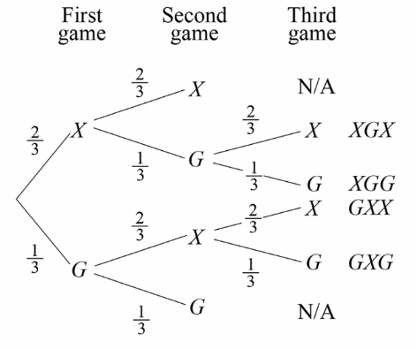
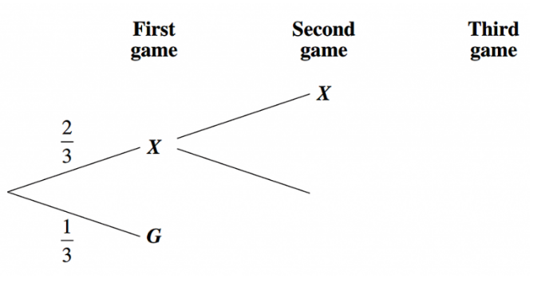
Xena and Gabrielle compete in a series of games. The series finishes when one player has won two games. In any game, the probability that Xena wins is $\frac{2}{3}$ and the probability that Gabrielle wins is $\frac{1}{3}$. Part of the tree diagram for this series of games is shown.

  - Complete the tree diagram, showing the possible outcomes (there are only 6).
  - What is the probability Gabrielle wins the series?
$$P\left(XGG\right)+P\left(GXG\right)+P\left(GG\right)=\frac{2}{27}+\frac{2}{27}+\frac{1}{9}=\frac{7}{27}$$
  - What is the probability three games are played in the series?
$$1-\left(P\left(XX\right)+P\left(GG\right)\right)=1-\left(\frac{4}{9}+\frac{1}{9}\right)=\frac{4}{9}$$

Probability of Compound Events using Venn Diagrams

- Mutually Exclusive Events
Mutually Exclusive  Mutually exclusive events cannot occur at the same time.  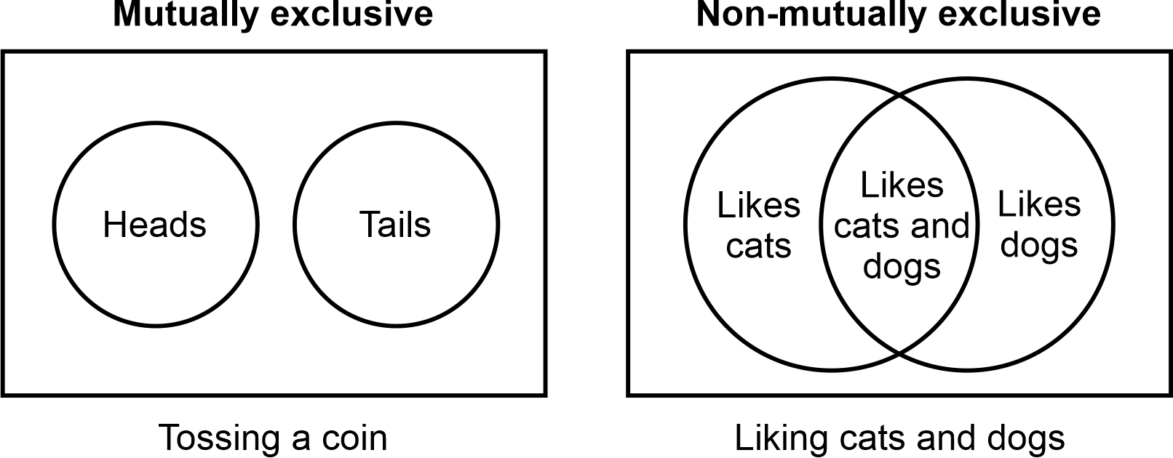  The Venn diagram does not overlap. | Non-mutually exclusive  Non-mutually exclusive events can occur at the same time.  The Venn diagram overlaps.

- Identify events as mutually exclusive or not.
- Liking maths, liking science  - Mutually exclusive  - Non-mutually exclusive | - Liking maths, not liking maths  - Mutually exclusive  - Non-mutually exclusive
- Even number, odd number  - Mutually exclusive  - Non-mutually exclusive | - Owning a dog, owning a cat  - Mutually exclusive  - Non-mutually exclusive
- Vowel, consonant  - Mutually exclusive  - Non-mutually exclusive | - Tossing a head, tossing a tail  - Mutually exclusive  - Non-mutually exclusive
- Having a tail, having four legs  - Mutually exclusive  - Non-mutually exclusive | - Winning a game, not winning a game  - Mutually exclusive  - Non-mutually exclusive

- Venn Diagrams
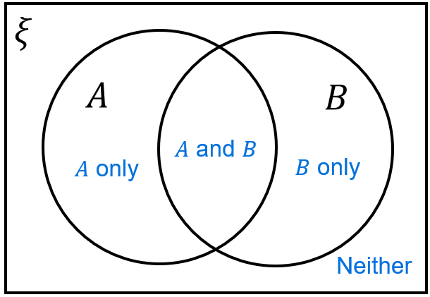
Venn diagrams visualise two events and their overlap.
When working with probability, the numbers represent the size of the sets.

- Interpret Venn diagrams
The Venn diagrams below represent a group of people who were surveyed on whether they like tea and coffee. Shade the area on the Venn diagram and two-way table that represents:
- People who like tea | - People who like coffee | 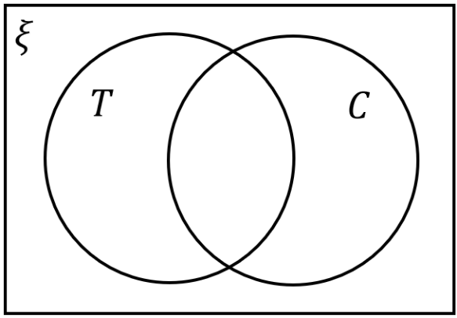  - People who like tea only
- People who like coffee only | - People who like both tea and coffee | - People who like tea or people who like coffee
- People who don’t like tea | - People who don’t like coffee | - People who like neither tea nor coffee
- Everyone surveyed | - People who like tea or coffee, but not both.

- Example Interpret Venn diagrams and two-way tables.
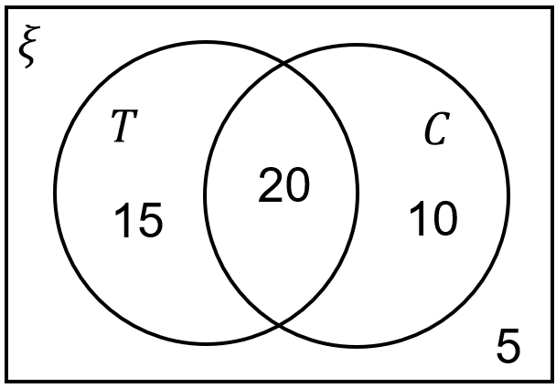
A survey was conducted to see people’s preferences on tea and coffee.
The data is recorded in the Venn diagram.

How many students:
- Were surveyed in total? 50 | - Like tea and coffee? 20
- Like tea or like coffee? 45 | - Like neither tea nor coffee? 5
- Like coffee only? 10 | - Like tea only? 15
- Like tea? 35 | - Like coffee? 30
- Dislike coffee? 20 | - Dislike tea? 15
What is the probability that a randomly selected person:
- Likes coffee?  $$P\left(T\right)=\frac{30}{50}=\frac{3}{5}$$ | - Likes tea and coffee?  $$P\left(T\right)=\frac{20}{50}=\frac{2}{5}$$

- Example Interpret Venn diagrams and two-way tables.
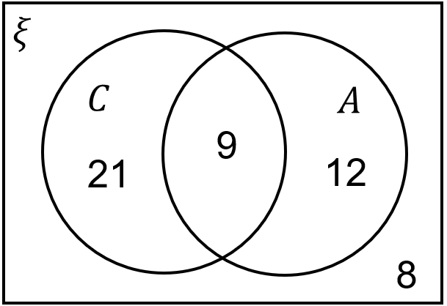
A survey was conducted to see people’s elective subjects.
The data is recorded in the Venn diagram.

How many students:
- Were surveyed?  50 | - Take Chinese and art?  9
- Take Chinese or art?  42 | - Take neither Chinese nor art?  8
- Take Art only?  12 | - Take Chinese only?  21
- Take Art?  21 | - Take Chinese?  30
- Don’t take Chinese?  20 | - Don’t take art?  29
What is the probability that a randomly selected person:
- Takes Chinese?  $$\frac{30}{50}=\frac{3}{5}$$ | - Takes art only?  $$\frac{12}{50}=\frac{6}{25}$$

- Constructing Venn Diagrams from a Scenario
- Read the entire scenario and identify what is given.
- Place “A only, “B only”, “both”, “neither” in its region.
- Find missing values by subtraction.

- Construct Venn diagrams from a scenario.
12 friends are at a party.
9 people eat chicken nuggets.
6 people eat salad.
2 people eat neither.
- Draw a Venn diagram to represent this information.
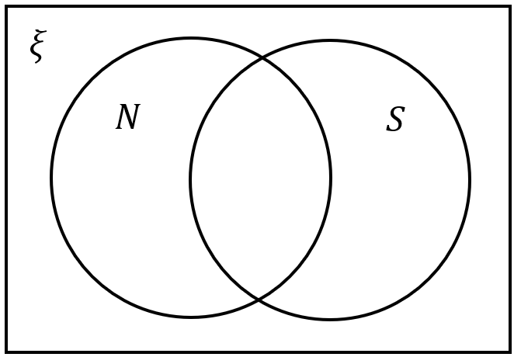

- Find the probability that a randomly chosen person ate both.

There are 30 girls in a class.
13 play tennis.
23 play netball.
7 girls play both.
- Draw a Venn diagram to represent this information.
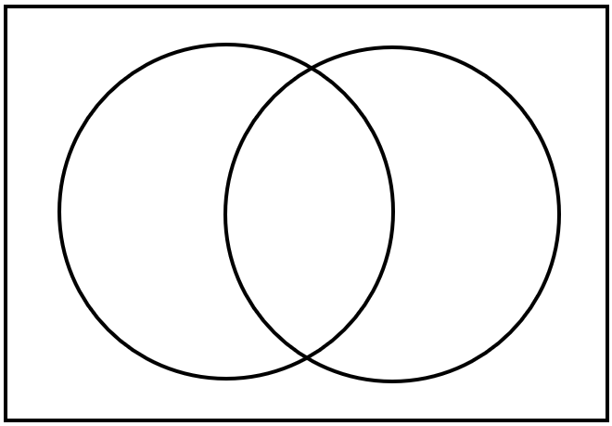

- What is the probability that a girl chosen at random plays neither sport?

Foundation
- A survey of 30 people found that 21 play AFL and 12 play soccer.
Also, 7 people play both AFL and soccer and 4 play neither AFL nor soccer.
  - Construct the Venn diagram for the survey results.
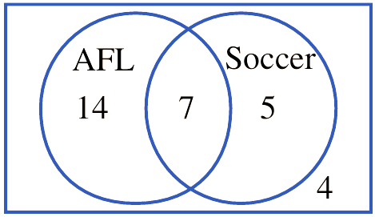

  - If one of the 30 people was randomly selected, find:
- $P\left(AFL or soccer\right)$  $$\frac{26}{30}=\frac{13}{15}$$ | - $P\left(do not play soccer\right)$  $$\frac{18}{30}=\frac{3}{5}$$ | - $P\left(only AFL\right)$  $$\frac{14}{30}=\frac{7}{15}$$

- For each Venn diagram, find the probabilities.
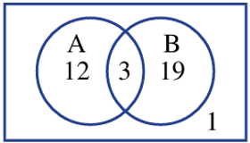  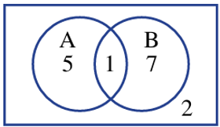  $$P\left(A\right)$$  $$\frac{2}{5}$$  $$P\left(A only\right)$$  $$\frac{1}{3}$$  $$P\left(not B\right)$$  $$\frac{7}{15}$$  $$P\left(A and B\right)$$  $$\frac{1}{15}$$  $$P\left(A or B\right)$$  $$\frac{13}{15}$$  $$P(neither A nor B)$$  $$\frac{2}{15}$$ | $$P\left(A\right)$$  $$\frac{3}{7}$$  $$P\left(A only\right)$$  $$\frac{12}{35}$$  $$P\left(not B\right)$$  $$\frac{13}{35}$$  $$P\left(A and B\right)$$  $$\frac{3}{35}$$  $$P\left(A or B\right)$$  $$\frac{34}{35}$$  $$P(neither A nor B)$$  $$\frac{1}{35}$$

Development
- The Venn diagram below shows the number of students speaking French and Italian in a classroom of 80 students.
First find the missing information, then find the probability that a randomly chosen student:
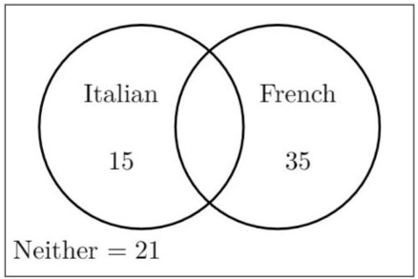
  - Speaks neither French nor Italian.
$$\frac{21}{80}$$
  - Speaks Italian or French, but not both.
$$\frac{5}{8}$$
  - Speaks Italian and French.
$$\frac{9}{80}$$
  - Speaks Italian or French.
$$\frac{59}{80}$$
- In a group of 50 students, there are 26 who study Latin, 15 who study Greek and 8 who study both languages. Draw a Venn diagram and find the probability that a student chosen at random:
  - studies only Latin,
  - studies only Greek,
  - does not study either

$$a)\frac{9}{25}$$
$$b)\frac{7}{50}$$
$$c)\frac{17}{50}$$

- Each student in a music class of 28 studies either the piano or the violin or both. It is known that 20 study the piano and 15 study the violin. Find the probability that a student selected at random studies both instruments.

$$\frac{1}{4}$$

Mastery
- Of 15 courier companies:
9 offer a local service (L), 7 offer an interstate service (S) and 6 offer an international service (I). 2 companies offer all three services, 3 offer both local and interstate services, 5 offer only local services and 1 offers only an international service.
  - Complete the Venn diagram to display the given information.
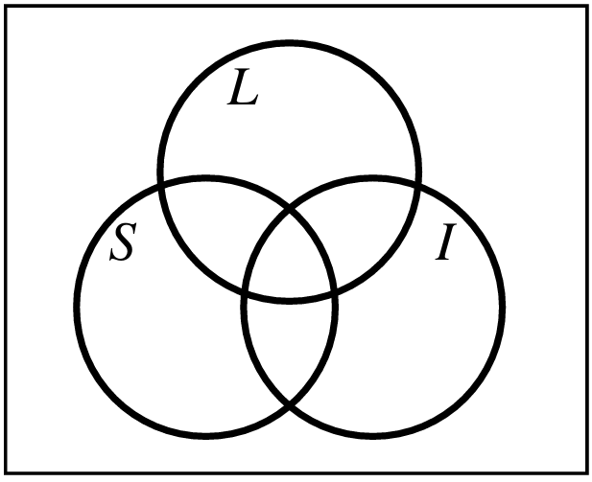
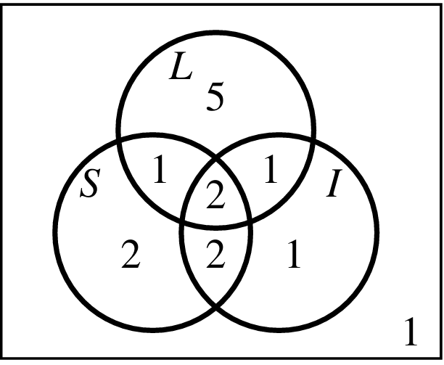

  - If a courier is chosen at random from the 15, find these probabilities:
- $P\left(L\right)$  $$\frac{3}{5}$$ | - $P\left(L only\right)$  $$\frac{1}{3}$$ | - $P\left(L or S\right)$  $$\frac{13}{15}$$ | - $P\left(L and S only\right)$  $$\frac{1}{15}$$

- 58 people took a trip to Europe to visit either France, England or Spain. Of this group,
26 visited France, 38 visited England, 29 visited Spain, 10 visited France and Spain,
12 visited only Spain, 13 visited only England and 8 visited all three countries.
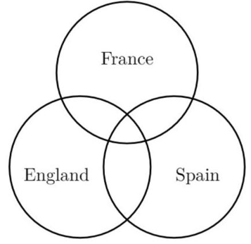

A person from the group of 58 was chosen at random. What is the probability that the person:
- Visited France only  $$\frac{3}{29}$$ | - Visited England and France  $$\frac{9}{29}$$ | - Visited only one country?  $$\frac{31}{58}$$
- Thirty-eight people were interviewed about their travelling experience in the past 12 months. The interviewer remembers the following information.
- 2 people travelled overseas, interstate and within their own state.
- 2 people travelled overseas and within their own state only.
- 7 people travelled interstate only.
- 22 people travelled within their own state.
- 3 people did not travel at all.
- The number of people who travelled interstate and within their own state only was twice the number of people who travelled overseas and interstate only.
- The number of people who travelled overseas was equal to the number of people who travelled within their own state only.
  - Fill in the Venn diagram.
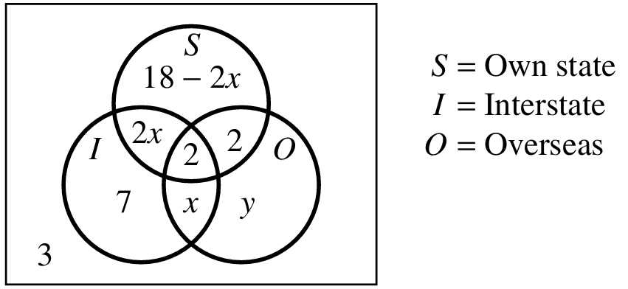
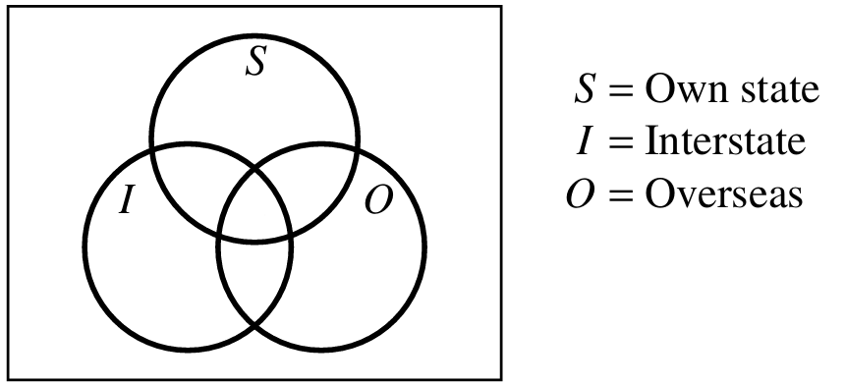

  - Let $x$ be the number of people two travelled overseas and interstate only.
Let $y$ be the number of travelled overseas only.
Solve simultaneously to find $x$ and $y$

$$x=4, y=2$$
  - If one person from the 38 is chosen at random, find the probability that they have travelled:
    - Within their own state only
$$\frac{5}{19}$$
    - Overseas only
$$\frac{1}{19}$$
    - Interstate only
$$\frac{7}{38}$$
    - Overseas or interstate or within their own state
$$\frac{35}{38}$$
    - Interstate or overseas
$$\frac{25}{38}$$

Compound Events, Venn Diagrams, Set Notation

- Compound Events using Venn Diagrams and Set Notation
$$P\left(A∪B\right)$$  Probability of either A or B.  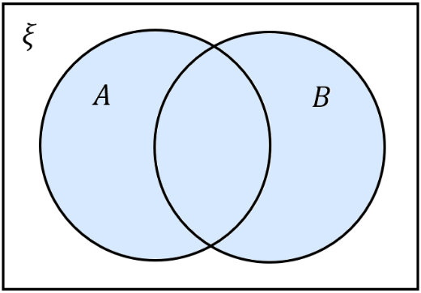 | $$P\left(A∩B\right)$$  Probability of both A and B.
$$P\left(A∩\overline{B}\right)$$  Probability of A only.  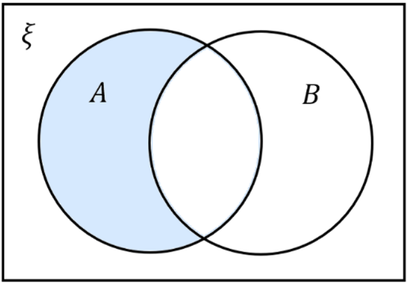 | $$P\left(\overline{A}∩B\right)$$  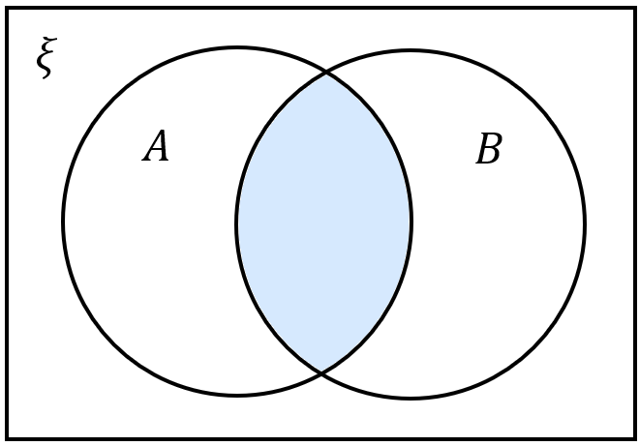  Probability of B only.  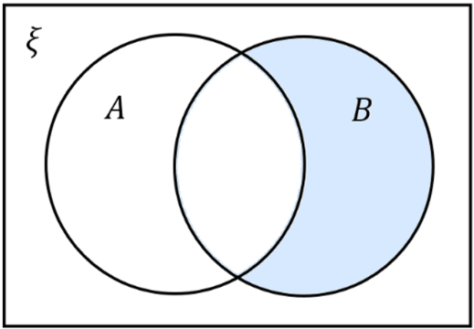  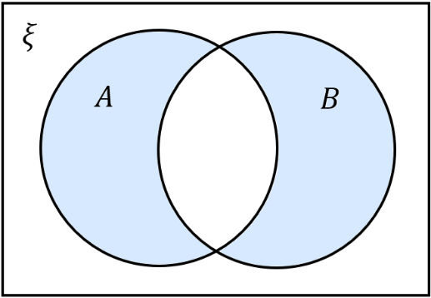
$$P\left(\overline{A}∩\overline{B}\right)=1-P\left(A∪B\right)$$  Probability of neither A nor B.  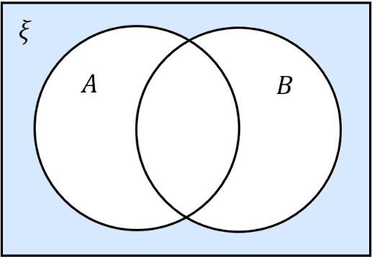 | $$P\left(A∪B\right)-P\left(A∩B\right)$$  Probability of A or B but not both.

- Addition Rule of Probability
$$P\left(A∪B\right)=P\left(A\right)+P\left(B\right)-P(A∩B)$$
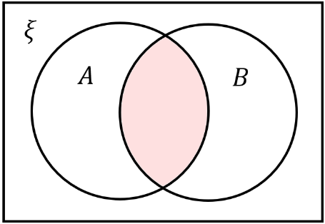
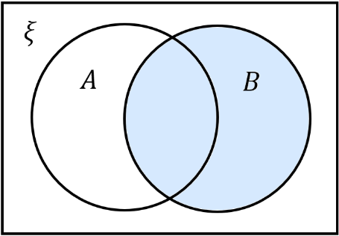
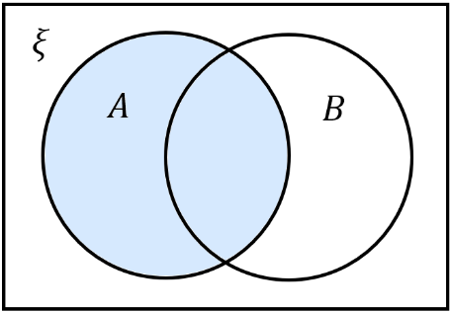
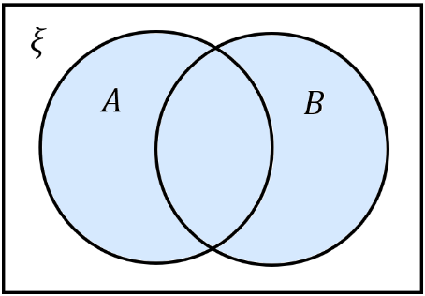

$=$ $+$ $-$

For two events that are mutually exclusive, $P\left(A∩B\right)=0$, so:
$$P\left(A∪B\right)=P\left(A\right)+P\left(B\right)$$
$ξ$
$A$
$B$

Always draw a Venn diagram to visualise the scenario rather than relying on the formulas.

- Example Applying the addition rule to probability.
One card is selected at random from a pack of 100 cards numbered from 1 to 100.  Let $A=\left\{even cards\right\}$  Let $B=\left\{cards less than 20\right\}$  Find $P\left(A∪B\right)$  $ξ$  $$B$$  $A$  $$P\left(A∪B\right)=P\left(A\right)+P\left(B\right)-P\left(A∩B\right) \\ =\frac{50}{100}+\frac{19}{100}-\frac{9}{100} \\ =\frac{3}{5}$$ | In a class of 30 girls, 13 play tennis and 23 play netball. 7 girls play both sports.  Let $T=\left\{students who do tennis\right\}$  Let $N=\left\{students who do netball\right\}$  Find $P\left(\overline{T}∩\overline{N}\right)$  $ξ$  $$N$$  $T$  $$P\left(T∪N\right)=P\left(T\right)+P\left(N\right)-P\left(T∩N\right) \\ =\frac{13}{30}+\frac{23}{30}-\frac{7}{30} \\ =\frac{29}{30} \\ P\left(\overline{T}∩\overline{N}\right)=1-P\left(T∪N\right) \\ =\frac{1}{30}$$

- Practice
A survey of 40 Year 9 students found that 18 students study French and 25 students study Drama. 8 students study both French and Drama.  Let $F=\left\{students who study French\right\}$  Let $D=\left\{student who study drama\right\}$  Find $P\left(F∩D\right)$  $ξ$  $$D$$  $F$  $$\frac{1}{5}$$ | In a library of 200 books, 85 books are fiction and 60 books were published recently. 30 books are both fiction and recent.  Let $F=\left\{Fiction books\right\}$  Let $R=\left\{Recent books\right\}$  Find $P\left(F∩\overline{R}\right)$  $ξ$  $$R$$  $F$  $$\frac{11}{40}$$

Foundation
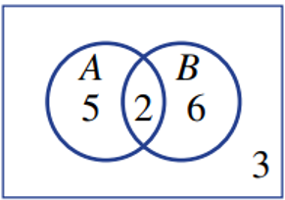
- The Venn diagram shows the distribution of elements in two sets, A and B.

  - Find:
- $n\left(A∩B\right)$  2 | - $n\left(A^{'}∩B\right)$  6 | - $n\left(A∩B^{'}\right)$  5 | - $n\left(A^{'}∩B^{'}\right)$  3
- $n\left(A\right)$  7 | - $n\left(B^{'}\right)$  8 | - $n\left(A∪B\right)$  13 | - $n\left(ξ\right)$  16

  - Find:
- $P\left(A∩B\right)$  $$\frac{1}{8}$$ | - $P\left(A^{'}\right)$  $$\frac{9}{16}$$ | - $P\left(A∩B^{'}\right)$  $$\frac{5}{16}$$

- From a total of 10 people, 5 like apples, 6 like bananas, and 4 like both.
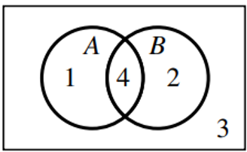
Draw a Venn diagram and find:
- $n\left(A^{'}∩B\right)$  $$2$$ | - $n\left(A^{'}∩B^{'}\right)$  $$3$$
- $P\left(A∩B\right)$  $$\frac{2}{5}$$ | - $P\left(A∪B\right)$  $$\frac{7}{10}$$

- A die is thrown. Let $A$ be the event that an even number appears.
Let $B$ be the event that a number greater than 2 appears.
  - Are A and B mutually exclusive?
No, since $A∩B=\left\{4,6\right\}≠∅$
  - Find:
- $P\left(A\right)$  $$P\left(A\right)=\frac{3}{6}=\frac{1}{2}$$ | - $P\left(B\right)$  $$P\left(B\right)=\frac{4}{6}=\frac{2}{3}$$ | - $P\left(A∩B\right)$  $$P\left(A ∩ B\right)=\frac{2}{6}=\frac{1}{3}$$ | - $P\left(A∪B\right)$  $$P\left(A\right)+ P\left(B\right)- P\left(A ∩ B\right)$$  $$=\frac{1}{2}+\frac{2}{3}-\frac{1}{3}=\frac{5}{6}$$

- A number is chosen from the set of positive integers between 1 and 20 inclusive.
A is the set of multiples of 3 less than 20, and B is the set of factors of 15.
Find the probabilities:
- $P(A∩B)$  A ∩ B = {3, 15}  $$\frac{2}{20}=\frac{1}{10}$$ | - $P(A∪B)$  A ∪ B = {1, 3, 5, 6, 9, 12, 15, 18}  $$\frac{8}{20}=\frac{2}{5}$$ | - $P(\overline{A})$  Ā = {1, 2, 4, 5, 7, 8, 10, 11, 13, 14, 16, 17, 19, 20}  $$\frac{14}{20}=\frac{7}{10}$$ | - $P(A∩\overline{B})$  A ∩ B̄ = {6, 9, 12, 18}  $$\frac{4}{20}=\frac{1}{5}$$

Development
- A card is selected from a standard deck of 52 playing cards (4 suits, no jokers).
Let A be the event 'the card is a diamond' and B be the event 'the card is a jack'.
  - Find:
- $P\left(A\right)$  $$\frac{13}{52}=\frac{1}{4}$$ | - $P\left(A^{'}\right)$  $$1-\frac{1}{4}=\frac{3}{4}$$ | - $P\left(A∩B\right)$  $$\frac{1}{52}$$

  - Use the addition rule to find $P\left(A∪B\right)$.
$$P\left(A∪B\right)=P\left(A\right)+ P\left(B\right)- P\left(A ∩ B\right)$$
$$\frac{13}{52}+\frac{4}{52}-\frac{1}{52}=\frac{4}{13}$$
  - Find the probability that the card is a jack or not a diamond.

$$P\left(B∪A^{'}\right)=P\left(B\right)+P\left(A^{'}\right)-P\left(B∩A^{'}\right)$$
$$=\frac{4}{52}+\frac{39}{52}-\frac{3}{52}=\frac{10}{13}$$

- $P\left(A\right)=$ $\frac{1}{2}$ $P\left(B\right)=$ $\frac{1}{3}$  Find:  - $P\left(\overline{A}\right)$  $$\frac{1}{2}$$  - $P\left(\overline{B}\right)$  $$\frac{2}{3}$$  - $P\left(A∩B\right)$  $$\frac{1}{3}$$  - $P\left(A∪B\right)$  $$\frac{1}{2}$$  - $P(\overline{A∪B})$  $$\frac{1}{2}$$ | - $P\left(A\right)=$ $\frac{2}{5}$ $P\left(B\right)=$ $\frac{1}{5}$  Find:  - $P\left(\overline{A}\right)$  $$\frac{3}{5}$$  - $P\left(\overline{B}\right)$  $$\frac{4}{5}$$  - $P\left(A∩B\right)$  $$\frac{3}{5}$$  - $P\left(A∪B\right)$  $$0$$  - $P(\overline{A∪B})$  $$1$$ | - $P\left(A\right)=$ $\frac{1}{2}$ $P\left(B\right)=$ $\frac{1}{3}$  $P\left(A∩B\right)=$ $\frac{1}{6}$  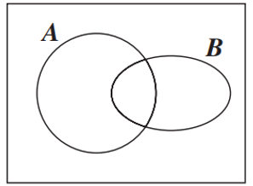  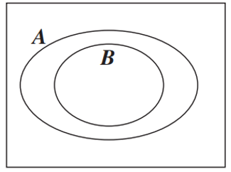  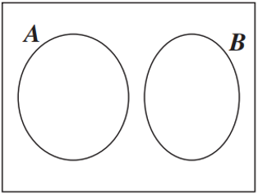  Find:  - $P\left(\overline{A}\right)$  $$\frac{1}{2}$$  - $P\left(\overline{B}\right)$  $$\frac{2}{3}$$  - $P\left(A∪B\right)$  $$\frac{2}{3}$$  - $P(\overline{A∪B})$  $$\frac{1}{3}$$  - $P(\overline{A∩B})$  $$\frac{5}{6}$$

Mastery
- Use the addition rule P(A ∪ B) = P(A) + P(B) - P(A ∩ B) to answer the following questions.
Drawing a Venn diagram helps.
  - If P(A) = $\frac{1}{5}$, P(B) = $\frac{1}{3}$ and P(A ∩ B) = $\frac{1}{15}$, find P(A ∪ B).

$$P\left(A ∪ B\right)= P\left(A\right)+ P\left(B\right)- P\left(A ∩ B\right)$$
$$=\frac{1}{5}+\frac{1}{3}-\frac{1}{15}=\frac{7}{15}$$
  - If P(A) = $\frac{1}{2}$, P(B) = $\frac{1}{3}$ and P(A ∪ B) = $\frac{5}{6}$, find P(A ∩ B).

$$P\left(A ∩ B\right)= P\left(A\right)+ P\left(B\right)- P\left(A ∪ B\right)$$
$$=\frac{1}{2}+\frac{1}{3}-\frac{5}{6}= 0$$
  - If P(A ∪ B) = $\frac{9}{10}$, (A ∩ B) = $\frac{1}{5}$ and P(A) = $\frac{1}{2}$, find P(B).

$$P\left(B\right)= P\left(A ∪ B\right)- P\left(A\right)+ P\left(A ∩ B\right)=\frac{9}{10}-\frac{1}{2}+\frac{1}{5}$$
$$=\frac{3}{5}$$
  - If A and B are mutually exclusive and P(A) = $\frac{1}{7}$ and P(B) = $\frac{4}{7}$, find P(A ∪ B).

If A and B are mutually exclusive, P(A ∩ B) = 0
$$P\left(A ∪ B\right)= P\left(A\right)+ P\left(B\right)- P\left(A ∩ B\right)=\frac{1}{7}+\frac{4}{7}- 0 =\frac{5}{7}$$

  - Find P(A ∩ B') when P(A ∪ B) = 0.8, P(A) = 0.5 and P(B) = 0.4

$$P(A ∪ B) = P(A) + P(B) - P(A ∩ B)$$
$$0.8 = 0.5 + 0.4 - P(A ∩ B)$$
$$P(A ∩ B) = 0.1$$
$$P\left(A ∩ B^{'}\right) = P(A) - P(A ∩ B) = 0.5 - 0.1 = 0.4$$
  - Find P ( A ′ ∩ B) when P (A ∪ B) = 0.76, P (A) = 0.31 and P (B) = 0.59

$$P(A ∪ B) = P(A) + P(B) - P(A ∩ B)$$
$$0.76 = 0.31 + 0.59 - P(A ∩ B)$$
$$P(A ∩ B) = 0.14$$
$$P(A'∩ B) = P(B) - P(A ∩ B) = 0.59 - 0.14 = 0.45$$

- 2012 VCE Band 4
A car manufacturer is reviewing the performance of its car model $X$.
It is known that at any given six-month service, the probability of model X requiring an oil change is $\frac{17}{20}$, the probability of model $X$ requiring an air filter change is $\frac{3}{20}$, and the probability of model $X$ requiring both is $\frac{1}{20}$.
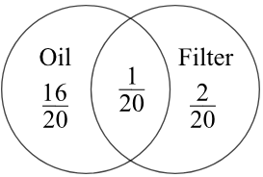
  - State the probability that at any given six-month service model $X$ will require an air filter change without an oil change.

$$P\left(A without O\right)= P\left(A ∩ O^{'}\right)= P\left(A\right)- P\left(A ∩ O\right)=\frac{3}{20}-\frac{1}{20}=\frac{2}{20}=\frac{1}{10}$$
  - The car manufacturer is developing a new model. The production goals are that the probability of model $Y$ requiring an oil change at any given six-month service will be $\frac{m}{m+n}$, the probability of model $Y$ requiring an air filter change will be $\frac{n}{m+n}$
and the probability of model $Y$ requiring both will be $\frac{1}{m+n}$, where m, n ∈ Z⁺.
Determine $m$ in terms of $n$ if the probability of model $Y$ requiring an air filter change without an oil change at any given six-month service is 0.05.
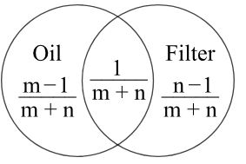
$$P\left(A without O\right)= P\left(A\right)- P\left(A ∩ O\right)=\frac{n}{m+n}-\frac{1}{m+n}=\frac{n-1}{m+n}$$
$$\frac{n-1}{m+n}=\frac{1}{20}$$
$$20\left(n-1\right)= m+n$$
$$20n - 20 = m + n$$
$$19n - 20 = m$$
$$∴ m = 19n - 20$$
- 2011 VCE Band 5
Two events, A and B, are such that P(A) = 3/5 and P(B) = 1/4.
If A' denotes the complement of A, calculate P(A' ∩ B) when:
  - P(A ∪ B) = $\frac{3}{4}$
  - A and B are mutually exclusive.
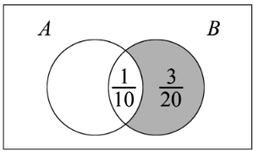
$a) Using P(A ∪ B) = P(A) + P(B) - P(A ∩ B)$
$$\frac{3}{4}=\frac{3}{5}+\frac{1}{4}- P\left(A ∩ B\right)$$
$$P\left(A ∩ B\right)=\frac{1}{10}$$
$$P\left(A^{'}∩ B\right)= P\left(B\right)- P\left(A ∩ B\right)=\frac{1}{4}-\frac{1}{10}=\frac{3}{20}$$
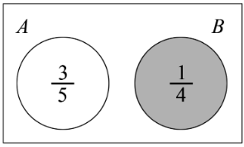
$$b) P\left(A^{'}∩B\right)=P\left(B\right)=\frac{1}{4}$$

